**CS/DSA 4513 - Database Management Systems – Section 001-Fall 2023**

INSTRUCTOR: Dr. Le Gruenwald

Author's Name: Anany Pratap Gupta

ID: 113496894

Email Address: Anany.p.gupta-1@ou.edu

Title of the Project: INDIVIDUAL PROJECT: A JOB-SHOP ACCOUNTING SYSTEM

[Today's Date] 11/16/2023

**Tasks Performed Page Number**

Task 1. ER Diagram 1

Task 2. Relational Database Schemas 2-3

Task 3. 4-20

* 1. Discussion of storage structures for tables 12-14
  2. Discussion of storage structures for tables (Azure SQL Database) 15-20

Task 4. SQL statements and screenshots showing the creation of 21-50

tables in Azure SQL Database

Task 5. 51-60

5,1 SQL statements **(and Transact SQL stored procedures, if any**) 51-54

Implementing all queries (1-15 and error checking)

5,2 The Java source program and screenshots showing 55-50

its successful compilation

Task 6. Java program Execution 51- 91

* 1. Screenshots showing the testing of query 1 51 - 53
  2. Screenshots showing the testing of query 2 63-65 . .

.

* 1. Screenshots showing the testing of query 14 80-81
  2. Screenshots showing the testing of the import and 85

export options

* 1. Screenshots showing the testing of three types of errors 87
  2. Screenshots showing the testing of the quit option 88

6.18 Error Teststing 89

**ER Diagram**

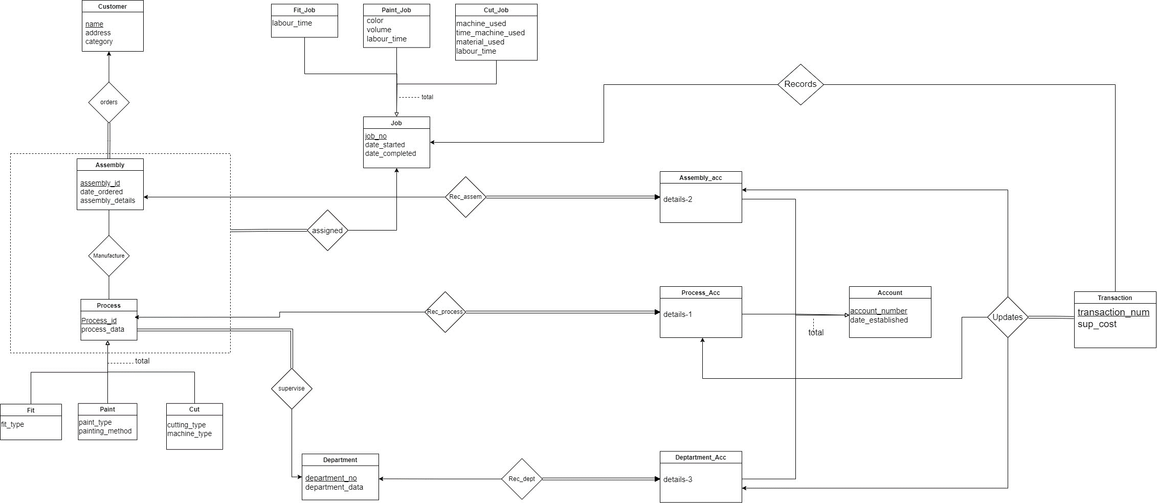

**Relational Schema**

Customer(name, address, category)

Assembly(assembly_id, date_ordered, assembly_details)

Orders(assembly_id, name)

Process(process_id, process_data,)

Fit(process_id, fit_type)

Paint(process_id, paint_type, painting method)

Cut(process_id, cutting_type, machine_type)

Job(job_no, date_started, date_completed)

Fit_Job(job_no, labour_time)

Paint_Job(job_no, color, volume, labour_time)

Cut_job(job_no, machine_used, time_machine_used, material_used, labour)

Manufacture(assembly_id, process_id, job_no)

Supervise(Process_id, department_no)

Department(department_no, department_data)

Process_acc(process_acc_num, details-1, date_established, process_id )

Assembly_acc(assembly_acc_num details-2, assembly_id, date_established, assembly_acc)

Department_acc(depart_acc_num, details-3, date_established, department_no)

Transact(transaction_num, sup_cost)

Records(transaction_num, job_no)

Updates(transaction_num, process_acc_num, assembly_acc_num, dept_acc_num)

Table Creation

-- Create tables

CREATE TABLE Customer (

    name VARCHAR(50) PRIMARY KEY,

    address VARCHAR(255),

    category INT

);

CREATE TABLE Assembly (

    assembly_id INT PRIMARY KEY,

    date_ordered DATE,

    assembly_details VARCHAR(255)

);

CREATE TABLE Orders (

    assembly_id INT,

    name VARCHAR(50),

    PRIMARY KEY (assembly_id),

    FOREIGN KEY (assembly_id) REFERENCES Assembly(assembly_id),

    FOREIGN KEY (name) REFERENCES Customer(name)

);

CREATE TABLE Process (

    process_id INT PRIMARY KEY,

    process_data VARCHAR(255)

);

CREATE TABLE Fit (

    process_id INT PRIMARY KEY,

    fit_type VARCHAR(255),

    FOREIGN KEY (process_id) REFERENCES Process(process_id)

);

CREATE TABLE Paint (

    process_id INT PRIMARY KEY,

    paint_type VARCHAR(255),

    painting_method VARCHAR(255),

    FOREIGN KEY (process_id) REFERENCES Process(process_id)

);

CREATE TABLE Cut (

    process_id INT PRIMARY KEY,

    cutting_type VARCHAR(255),

    machine_type VARCHAR(255),

    FOREIGN KEY (process_id) REFERENCES Process(process_id)

);

CREATE TABLE Job (

    job_no INT PRIMARY KEY,

    date_started DATE,

    date_completed DATE

);

CREATE TABLE Fit_Job (

    job_no INT PRIMARY KEY,

    labour_time INT,

    FOREIGN KEY (job_no) REFERENCES Job(job_no)

);

CREATE TABLE Paint_Job (

    job_no INT PRIMARY KEY,

    color VARCHAR(50),

    volume VARCHAR(20),

    labour_time INT,

    FOREIGN KEY (job_no) REFERENCES Job(job_no)

);

CREATE TABLE Cut_Job (

    job_no INT PRIMARY KEY,

    machine_used VARCHAR(50),

    time_machine_used VARCHAR(20),

    material_used VARCHAR(50),

    labour_time INT,

    FOREIGN KEY (job_no) REFERENCES Job(job_no)

);

CREATE TABLE Manufacture (

    assembly_id INT,

    process_id INT,

    job_no INT,

    PRIMARY KEY (assembly_id, process_id, job_no),

    FOREIGN KEY (assembly_id) REFERENCES Assembly(assembly_id),

    FOREIGN KEY (process_id) REFERENCES Process(process_id),

    FOREIGN KEY (job_no) REFERENCES Job(job_no)

);

CREATE TABLE Supervise (

    process_id INT,

    department_no INT,

    PRIMARY KEY (process_id, department_no),

    FOREIGN KEY (process_id) REFERENCES Process(process_id)

);

CREATE TABLE Department (

    department_no INT PRIMARY KEY,

    department_data VARCHAR(255)

);

CREATE TABLE Process_acc (

    process_acc_num INT PRIMARY KEY,

    details_1 INT,

    date_established DATE,

    process_id INT,

    FOREIGN KEY (process_id) REFERENCES Process(process_id)

);

CREATE TABLE Assembly_acc (

    assembly_acc_num INT PRIMARY KEY,

    details_2 INT,

    assembly_id INT,

    date_established DATE,

    FOREIGN KEY (assembly_id) REFERENCES Assembly(assembly_id)

);

CREATE TABLE Department_acc (

    depart_acc_num INT PRIMARY KEY,

    details_3 INT,

    date_established DATE,

    department_no INT,

    FOREIGN KEY (department_no) REFERENCES Department(department_no)

);

CREATE TABLE Transact (

    transaction_num INT PRIMARY KEY,

    sup_cost INT

);

CREATE TABLE Records (

    transaction_num INT PRIMARY KEY,

    job_no INT,

    FOREIGN KEY (job_no) REFERENCES Job(job_no),

    FOREIGN KEY (transaction_num) REFERENCES Transact(transaction_num)

);

CREATE TABLE Updates (

    transaction_num INT PRIMARY KEY,

    process_acc_num INT,

    assembly_acc_num INT,

    dept_acc_num INT,

    FOREIGN KEY (process_acc_num) REFERENCES Process_acc(process_acc_num),

    FOREIGN KEY (assembly_acc_num) REFERENCES Assembly_acc(assembly_acc_num),

    FOREIGN KEY (dept_acc_num) REFERENCES Department_acc(depart_acc_num),

    FOREIGN KEY (transaction_num) REFERENCES Transact(transaction_num)

);

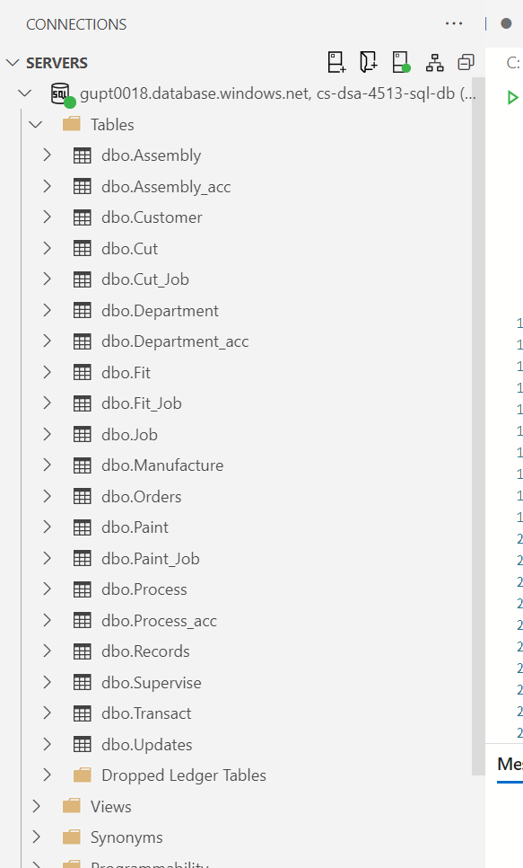

5,1 SQL statements Implementing all queries

--CREATE PROCEDURE <Procedure_Name>

--AS

--BEGIN

--<SQL Statement(s)>

--END

--GO

-- 1. Enter a new customer

DROP PROCEDURE IF EXISTS EnterNewCustomer;

GO

CREATE PROCEDURE EnterNewCustomer

    @p_name VARCHAR(255),

    @p_address VARCHAR(255),

    @p_category INT

AS

BEGIN

    INSERT INTO Customer (name, address, category) VALUES (@p_name, @p_address, @p_category);

END;

--GO

--EXEC EnterNewCustomer @p_name = 'test', @p_address = "test address", @p_category = 3;

-- 2. Enter a new department

DROP PROCEDURE IF EXISTS EnterNewDepartment;

GO

CREATE PROCEDURE EnterNewDepartment

    @p_department_no INT,

    @p_department_data VARCHAR(255)

AS

BEGIN

    INSERT INTO Department (department_no, department_data) VALUES (@p_department_no, @p_department_data);

END;

--GO

--EXEC EnterNewDepartment @p_department_no = 1, @p_department_data = "test1";

-- 3. Enter a new process-id and its department together with its type and information relevant to the type

DROP PROCEDURE IF EXISTS EnterNewProcess;

GO

CREATE PROCEDURE EnterNewProcess

    @p_process_id INT,

    @p_process_data VARCHAR(255),

    @p_department_no INT,

    @p_type VARCHAR(10),

    @p_fit_type VARCHAR(255),

    @p_paint_type VARCHAR(255),

    @p_paint_method VARCHAR(255),

    @p_cutting_type VARCHAR(255),

    @p_machine_type VARCHAR(255)

AS

BEGIN

    INSERT INTO Process (process_id, process_data) VALUES (@p_process_id, @p_process_data);

    IF @p_type = 'Fit'

    BEGIN

        INSERT INTO Fit (process_id, fit_type) VALUES (@p_process_id, @p_fit_type);

    END

    ELSE IF @p_type = 'Paint'

    BEGIN

        INSERT INTO Paint (process_id, paint_type, painting_method) VALUES (@p_process_id, @p_paint_type, @p_paint_method);

    END

    ELSE IF @p_type = 'Cut'

    BEGIN

        INSERT INTO Cut (process_id, cutting_type, machine_type) VALUES (@p_process_id, @p_cutting_type, @p_machine_type);

    END

    INSERT INTO Supervise (process_id, department_no) VALUES (@p_process_id, @p_department_no);

END;

--GO

--EXEC EnterNewProcess  @p_process_id = 2,  @p_process_data = 'Process 2',  @p_department_no = 10,  @p_type = 'Fit',  @p_fit_type = 'test_fit', @p_paint_type = NULL, @p_paint_method = NULL,  @p_cutting_type = NULL,  @p_machine_type = NULL;

-- 4. Enter a new assembly with its customer-name, assembly-details, assembly-id, and dateordered

DROP PROCEDURE IF EXISTS EnterNewAssembly;

GO

CREATE PROCEDURE EnterNewAssembly

    @p_assembly_id INT,

    @p_date_ordered DATE,

    @p_assembly_details VARCHAR(255),

    @p_customer_name VARCHAR(255)

AS

BEGIN

    -- Insert into Assembly

    INSERT INTO Assembly (assembly_id, date_ordered, assembly_details) VALUES (@p_assembly_id, @p_date_ordered, @p_assembly_details);

    -- Insert into Orders

    INSERT INTO Orders (assembly_id, name) VALUES (@p_assembly_id, @p_customer_name);

END;

--GO

--EXEC EnterNewAssembly @p_assembly_id = 3, @p_date_ordered = '2023-01-01', @p_assembly_details = 'Assembly 2', @p_customer_name = 'Test';

-- 5. Create a new account and associate it with the process, assembly, or department

DROP PROCEDURE IF EXISTS CreateNewAccount;

GO

CREATE PROCEDURE CreateNewAccount

    @account_type VARCHAR(15),

    @process_account_num INT,

    @assembly_account_num INT,

    @department_account_num INT,

    @date_established DATE,

    @p_details_1 INT,

    @p_details_2 INT,

    @p_details_3 INT,

    @p_process_id INT,

    @p_assembly_id INT,

    @p_department_no INT

AS

BEGIN

    IF @account_type = 'Process'

    BEGIN

        INSERT INTO Process_acc (process_acc_num, details_1, date_established, process_id) VALUES (@process_account_num, @p_details_1, @date_established, @p_process_id);

    END

    ELSE IF @account_type = 'Assembly'

    BEGIN

         INSERT INTO Assembly_acc (assembly_acc_num, details_2, date_established, assembly_id) VALUES (@assembly_account_num, @p_details_2, @date_established, @p_assembly_id);

    END

    ELSE IF @account_type = 'Department'

    BEGIN

        INSERT INTO Department_acc (depart_acc_num, details_3, date_established, department_no) VALUES (@department_account_num, @p_details_3, @date_established, @p_department_no);

    END

END;

--GO

--EXEC CreateNewAccount @account_type = 'Assembly', @process_account_num = NULL, @assembly_account_num = 1, @department_account_num = NULL, @date_established = '2023-11-14', @p_details_1 = NULL, @p_details_2 = 'test_details 1', @p_details_3 = NULL,  @p_process_id = NULL, @p_assembly_id = 1, @p_department_no = NULL;

-- 6. Enter a new job, given its job-no, assembly-id, process-id, and date the job commenced

DROP PROCEDURE IF EXISTS EnterNewJob;

GO

CREATE PROCEDURE EnterNewJob

    @p_job_no INT,

    @p_assembly_id INT,

    @p_process_id INT,

    @p_date_started DATE

AS

BEGIN

    INSERT INTO Job (job_no, date_started) VALUES (@p_job_no, @p_date_started);

    -- Insert into Assigned

    INSERT INTO Manufacture(assembly_id, process_id, job_no) VALUES (@p_assembly_id, @p_process_id, @p_job_no);

END;

--GO

--EXEC EnterNewJob @p_job_no = 1, @p_assembly_id = 1, @p_process_id = '1', @p_date_started = '2023-01-01';

-- 7. At the completion of a job, enter the date it completed and the information relevant to the type of job

DROP PROCEDURE IF EXISTS CompleteJob;

GO

CREATE PROCEDURE CompleteJob

    @job_type VARCHAR(15),

    @p_job_no INT,

    @p_date_completed DATE,

    @labour_time VARCHAR(20),

    @color VARCHAR(50),

    @volume VARCHAR(20),

    @machine_used VARCHAR(50),

    @time_machine_used VARCHAR(50),

    @material_used VARCHAR(50)

AS

BEGIN

    UPDATE Job SET date_completed = @p_date_completed WHERE job_no = @p_job_no;

    IF @job_type = 'Fit'

    BEGIN

        INSERT INTO Fit_Job (job_no, labour_time)

        VALUES (@p_job_no, @labour_time);

    END

    ELSE IF @job_type = 'Paint'

    BEGIN

        INSERT INTO Paint_Job (job_no, labour_time, color, volume)

        VALUES (@p_job_no, @labour_time, @color, @volume);

    END

    ELSE IF @job_type = 'Cut'

    BEGIN

        INSERT INTO Cut_Job (job_no, time_machine_used, machine_used, material_used, labour_time)

        VALUES (@p_job_no, @time_machine_used, @machine_used, @material_used, @labour_time);

    END

END;

--GO

--EXEC CompleteJob @job_type = 'Fit', @p_job_no = 1, @p_date_completed = '2023-02-02', @labour_time = "1 hour", @color = NULL, @volume = NULL,  @machine_used = 'your-machine', @time_machine_used = NULL, @material_used = 'your-material';

-- 8.   Enter a transaction-no and its sup-cost and update all the costs (details) of the affected accounts by adding sup-cost to their current values of details

DROP PROCEDURE IF EXISTS UpdateAccountDetailsWithInsert;

GO

-- Create the procedure

CREATE PROCEDURE UpdateAccountDetailsWithInsert

    @p_transaction_num INT,

    @p_sup_cost INT,

    @p_assembly_acc_num INT,

    @p_dept_acc_num INT,

    @p_process_acc_num INT

AS

BEGIN

    -- 1. Insert into Transact table

    INSERT INTO Transact (transaction_num, sup_cost)

    VALUES (@p_transaction_num, @p_sup_cost);

    -- 5. Insert into Updates table

    INSERT INTO Updates (transaction_num, process_acc_num, assembly_acc_num, dept_acc_num)

    VALUES (@p_transaction_num, @p_process_acc_num, @p_assembly_acc_num, @p_dept_acc_num);

    -- 2. Update Assembly Account details

    UPDATE Assembly_acc

    SET details_2 = details_2 + @p_sup_cost

    WHERE assembly_acc_num = @p_assembly_acc_num;

    -- 3. Update Department Account details

    UPDATE Department_acc

    SET details_3 = details_3 + @p_sup_cost

    WHERE depart_acc_num = @p_dept_acc_num;

    -- 4. Update Process Account details

    UPDATE Process_acc

    SET details_1 = details_1 + @p_sup_cost

    WHERE process_acc_num = @p_process_acc_num;

END;

--9.    Retrieve the total cost incurred on an assembly-id (200/day).

DROP PROCEDURE IF EXISTS GetTotalCostForAssembly;

GO

-- Create the procedure

CREATE PROCEDURE GetTotalCostForAssembly

    @p_assembly_id INT

AS

BEGIN

    SELECT a.assembly_id,

           COALESCE(SUM(p.details_1), 0) + COALESCE(SUM(a.details_2), 0) + COALESCE(SUM(d.details_3), 0) AS total_cost

    FROM Assembly_acc a

    LEFT JOIN Updates u ON a.assembly_acc_num = u.assembly_acc_num

    LEFT JOIN Transact t ON u.transaction_num = t.transaction_num

    LEFT JOIN Process_acc p ON u.process_acc_num = p.process_acc_num

    LEFT JOIN Department_acc d ON u.dept_acc_num = d.depart_acc_num -- Corrected column name

    WHERE a.assembly_id = @p_assembly_id

    GROUP BY a.assembly_id;

END;

-- 10. Retrieve the total labor time within a department for all completed jobs in the department.

DROP PROCEDURE IF EXISTS GetTotalLaborTimeInDepartment;

GO

CREATE PROCEDURE GetTotalLaborTimeInDepartment

    @p_department_no INT

AS

BEGIN

    -- Step 1: Select all processes connected to the given department number

    SELECT p.process_id

    INTO #TempProcesses

    FROM Process p

    JOIN Supervise s ON p.process_id = s.process_id

    WHERE s.department_no = @p_department_no;

    -- Step 2: Select all jobs connected to the selected processes

    SELECT j.job_no

    INTO #TempJobs

    FROM Job j

    JOIN Manufacture m ON j.job_no = m.job_no

    WHERE m.process_id IN (SELECT process_id FROM #TempProcesses);

    -- Step 3: Select completed jobs

    SELECT job_no, labour_time

    INTO #CompletedJobs

    FROM Fit_Job

    WHERE job_no IN (SELECT job_no FROM #TempJobs)

    UNION

    SELECT job_no, labour_time

    FROM Paint_Job

    WHERE job_no IN (SELECT job_no FROM #TempJobs)

    UNION

    SELECT job_no, labour_time

    FROM Cut_Job

    WHERE job_no IN (SELECT job_no FROM #TempJobs)

    AND job_no IN (

        SELECT job_no

        FROM Job

        WHERE date_completed IS NOT NULL

    );

    -- Step 4: Calculate and retrieve the total labor time

    SELECT SUM(labour_time) AS total_labor_time

    FROM #CompletedJobs;

    -- Clean up temporary tables

    DROP TABLE #TempProcesses;

    DROP TABLE #TempJobs;

    DROP TABLE #CompletedJobs;

END;

--GO

--EXEC GetTotalLaborTimeInDepartment @p_department_no = 1;

-- 11. Retrieve the processes and departments for a given assembly-id

DROP PROCEDURE IF EXISTS GetProcessesAndDepartmentsForAssembly;

GO

CREATE PROCEDURE GetProcessesAndDepartmentsForAssembly

    @p_assembly_id INT

AS

BEGIN

    -- Step 1: Select all processes connected to the given assembly-id

    SELECT p.process_id, p.process_data, s.department_no, d.department_data

    INTO #AssemblyProcesses

    FROM Process p

    JOIN Supervise s ON p.process_id = s.process_id

    JOIN Manufacture m ON p.process_id = m.process_id

    JOIN Department d ON s.department_no = d.department_no

    WHERE m.assembly_id = @p_assembly_id

    ORDER BY (SELECT MIN(j.date_started) FROM Job j WHERE j.job_no = m.job_no); -- Order by date commenced

    -- Step 2: Return the result

    SELECT * FROM #AssemblyProcesses;

    -- Clean up temporary table

    DROP TABLE #AssemblyProcesses;

END;

--GO

--EXEC GetProcessesAndDepartmentsForAssembly @p_assembly_id = 1;

--12.   Retrieve the customers (in name order) whose category is in a given range (100/day).

DROP PROCEDURE IF EXISTS GetCustomersInCategoryRange;

GO

CREATE PROCEDURE GetCustomersInCategoryRange

    @p_lower_range INT,

    @p_upper_range INT

AS

BEGIN

    SELECT name, address, category

    FROM Customer

    WHERE category BETWEEN @p_lower_range AND @p_upper_range

    ORDER BY name;

END;

--13.   Delete all cut-jobs whose job-no is in a given range (1/month).

DROP PROCEDURE IF EXISTS DeleteCutJobsInRange;

GO

CREATE PROCEDURE DeleteCutJobsInRange

    @p_lower_range INT,

    @p_upper_range INT

AS

BEGIN

    DELETE FROM Cut_Job

    WHERE job_no BETWEEN @p_lower_range AND @p_upper_range;

END;

--14.   Change the color of a given paint job (1/week).

DROP PROCEDURE IF EXISTS ChangePaintJobColor;

GO

CREATE PROCEDURE ChangePaintJobColor

    @p_job_no INT,

    @p_new_color VARCHAR(50)

AS

BEGIN

    UPDATE Paint_Job

    SET color = @p_new_color

    WHERE job_no = @p_job_no;

END;

Java Code

import java.sql.Connection;

import java.sql.Statement;

import java.util.Scanner;

import java.sql.ResultSet;

import java.sql.SQLException;

import java.sql.DriverManager;

import java.sql.PreparedStatement;

import java.io.BufferedReader;

import java.io.FileReader;

import java.io.IOException;

import java.io.BufferedWriter;

import java.io.FileWriter;

import java.io.IOException;

import java.sql.ResultSet;

public class IndividualProject {

// Database credentials

final static String HOSTNAME = "gupt0018.database.windows.net";

final static String DBNAME = "cs-dsa-4513-sql-db";

final static String USERNAME = "gupt0018";

final static String PASSWORD = "Kiro&guchi@123";

// Database connection string

final static String URL = String.format("jdbc:sqlserver://%s:1433;database=%s;user=%s;password=%s;encrypt=true;trustServerCertificate=false;hostNameInCertificate=*.database.windows.net;loginTimeout=30;",

HOSTNAME, DBNAME, USERNAME, PASSWORD);

//>>>>>>>>>>>>>>>>>>>>>>>>>>>>>DO NOT TOUCH CODE ABOVE THIS<<<<<<<<<<<<<<<<<<<<<<<<<<<<<<<<<<<<<<<<<<

// Query templates

final static String ENTER_NEW_CUSTOMER = "{call EnterNewCustomer(?, ?, ?)}";

final static String ENTER_NEW_DEPARTMENT = "{call EnterNewDepartment(?, ?)}";

final static String ENTER_NEW_PROCESS = "{call EnterNewProcess(?, ?, ?, ?, ?, ?, ?, ?, ?)}";

final static String ENTER_NEW_ASSEMBLY = "{call EnterNewAssembly(?, ?, ?, ?)}";

final static String CREATE_NEW_ACCOUNT = "{call CreateNewAccount(?, ?, ?, ?, ?, ?, ?, ?, ?, ?, ?)}";

final static String ENTER_NEW_JOB = "{call EnterNewJob(?, ?, ?, ?)}";

final static String COMPLETE_JOB = "{call CompleteJob(?, ?, ?, ?, ?, ?, ?, ?, ?)}";

final static String UPDATE_ACCOUNT_DETAILS = "{call UpdateAccountDetailsWithInsert(?, ?, ?, ?, ?)}";

final static String GET_TOTAL_COST_FOR_ASSEMBLY = "{call GetTotalCostForAssembly(?)}";

final static String GET_TOTAL_LABOR_TIME_IN_DEPARTMENT = "{call GetTotalLaborTimeInDepartment(?)}";

final static String GET_PROCESSES_FOR_ASSEMBLY = "{call GetProcessesAndDepartmentsForAssembly(?)}";

final static String GET_CUSTOMERS_IN_CATEGORY_RANGE = "{call GetCustomersInCategoryRange(?, ?)}";

final static String DELETE_CUT_JOBS_IN_RANGE = "{call DeleteCutJobsInRange(?, ?)}";

final static String CHANGE_PAINT_JOB_COLOR = "{call ChangePaintJobColor(?, ?)}";

// User input prompt//

final static String PROMPT = "WELCOME TO THE JOB-SHOP ACCOUNTING DATABASE SYSTEM \r\n"

+ " \r\n"

+ "(1)Enter a new customer \r\n"

+ "(2)Enter a new department \r\n"

+ "(3)Enter a new process-id and its department together with its type and information relevant to the type \r\n"

+ "(4)Enter a new assembly with its customer-name, assembly-details, assembly-id, and dateordered and associate it with one or more processes (40/day). \r\n"

+ "(5)Create a new account and associate it with the process, assembly, or department to which it is applicable \r\n"

+ "(6)Enter a new job, given its job-no, assembly-id, process-id, and date the job commenced \r\n"

+ "(7)At the completion of a job, enter the date it completed and the information relevant to the type of job \r\n"

+ "(8)Enter a transaction-no and its sup-cost and update all the costs (details) of the affected accounts by adding sup-cost to their current values of details \r\n"

+ "(9)Retrieve the total cost incurred on an assembly-id \r\n"

+ "(10)Retrieve the total labor time within a department for jobs completed in the department during a given date \r\n"

+ "(11)Retrieve the processes through which a given assembly-id has passed so far (in datecommenced order) and the department responsible for each process \r\n"

+ "(12)Retrieve the customers (in name order) whose category is in a given range \r\n"

+ "(13)Delete all cut-jobs whose job-no is in a given range \r\n"

+ "(14)Change the color of a given paint job \r\n"

+ "(15)Import: enter new customers from a data file until the file is empty (the user must be asked to enter the input file name). \r\n"

+ "(16)Export: Retrieve the customers (in name order) whose category is in a given range and output them to a data file instead of screen (the user must be asked to enter the output file name). \r\n"

+ "(17)Quit \r\n"

+ "";

public static void main(String[] args) throws SQLException {

System.out.println("Welcome to Individual project");

final Scanner sc = new Scanner(System.in); // Scanner is used to collect the user input

String option = ""; // Initialize user option selection as nothing

while (!option.equals("17"))

{ // As user for options until option 3 is selected

System.out.println(PROMPT); // Print the available options

option = sc.next(); // Read in the user option selection

switch (option)

{ // Switch between different options

case "1": // Enter a new customer

// Collect the new customer data from the user

System.out.println("Please enter customer name: ");

sc.nextLine();

final String name = sc.nextLine(); // Read in the user input of customer name

System.out.println("Please enter customer address:");

final String address = sc.nextLine(); // Read in user input of customer address

System.out.println("Please enter customer category (1-10):");

final int category = sc.nextInt(); // Read in user input of customer category

System.out.println("Connecting to the database...");

// Get a database connection and prepare a query statement

try (final Connection connection = DriverManager.getConnection(URL)) {

try (final PreparedStatement statement = connection.prepareCall(ENTER_NEW_CUSTOMER)) {

// Populate the query template with the data collected from the user

statement.setString(1, name);

statement.setString(2, address);

statement.setInt(3, category);

System.out.println("Dispatching the query...");

// Actually execute the populated query

final int rows_inserted = statement.executeUpdate();

System.out.println(String.format("Done. %d rows inserted.", rows_inserted));

}

}

break;

case "2": // Enter a new department

// Collect the new department data from the user

System.out.println("Please enter department number: ");

final int departmentNo = sc.nextInt(); // Read in the user input of department number

System.out.println("Please enter department data:");

sc.nextLine(); // Consuming the trailing new line character left after nextInt

final String departmentData = sc.nextLine(); // Read in user input of department data

System.out.println("Connecting to the database...");

// Get a database connection and prepare a query statement

try (final Connection connection = DriverManager.getConnection(URL)) {

try (final PreparedStatement statement = connection.prepareCall(ENTER_NEW_DEPARTMENT)) {

// Populate the query template with the data collected from the user

statement.setInt(1, departmentNo);

statement.setString(2, departmentData);

System.out.println("Dispatching the query...");

// Actually execute the populated query

final int rows_inserted = statement.executeUpdate();

System.out.println(String.format("Done. %d rows inserted.", rows_inserted));

}

}

break;

case "3": // Enter a new process

System.out.println("Please enter process ID:");

final int processId = sc.nextInt(); // Read in user input of process ID

System.out.println("Please enter process data:");

sc.nextLine();

final String processData = sc.nextLine(); // Read in user input of process data

System.out.println("Please enter department number:");

final int departmentNoProcess = sc.nextInt(); // Read in user input of department number

System.out.println("Please enter process type (Fit/Paint/Cut):");

sc.nextLine();

final String processType = sc.nextLine(); // Read in user input of process type

// Collect additional information based on the process type

String fitType = null, paintType = null, paintMethod = null, cuttingType = null, machineType = null;

switch (processType.toLowerCase()) {

case "fit":

System.out.println("Please enter fit type:");

fitType = sc.nextLine();

break;

case "paint":

System.out.println("Please enter paint type:");

paintType = sc.nextLine();

System.out.println("Please enter painting method:");

paintMethod = sc.nextLine();

break;

case "cut":

System.out.println("Please enter cutting type:");

cuttingType = sc.nextLine();

System.out.println("Please enter machine type:");

machineType = sc.nextLine();

break;

default:

System.out.println("Invalid process type.");

return;

}

System.out.println("Connecting to the database...");

// Get a database connection and prepare a query statement

try (final Connection connection = DriverManager.getConnection(URL)) {

try (final PreparedStatement statement = connection.prepareCall(ENTER_NEW_PROCESS)) {

// Populate the query template with the data collected from the user

statement.setInt(1, processId);

statement.setString(2, processData);

statement.setInt(3, departmentNoProcess);

statement.setString(4, processType);

statement.setString(5, fitType);

statement.setString(6, paintType);

statement.setString(7, paintMethod);

statement.setString(8, cuttingType);

statement.setString(9, machineType);

System.out.println("Dispatching the query...");

// Actually execute the populated query

final int rows_inserted = statement.executeUpdate();

System.out.println(String.format("Done. %d rows inserted.", rows_inserted));

}

}

break;

case "4": // Enter a new assembly

System.out.println("Please enter assembly ID:");

final int assemblyId = sc.nextInt(); // Read in user input of assembly ID

System.out.println("Please enter date ordered (YYYY-MM-DD):");

sc.nextLine(); // Consume the newline character

final String dateOrdered = sc.nextLine(); // Read in user input of date ordered

System.out.println("Please enter assembly details:");

final String assemblyDetails = sc.nextLine(); // Read in user input of assembly details

System.out.println("Please enter customer name:");

final String customerName = sc.nextLine(); // Read in user input of customer name

System.out.println("Connecting to the database...");

// Get a database connection and prepare a query statement

try (final Connection connection = DriverManager.getConnection(URL)) {

try (final PreparedStatement statement = connection.prepareCall(ENTER_NEW_ASSEMBLY)) {

// Populate the query template with the data collected from the user

statement.setInt(1, assemblyId);

statement.setDate(2, java.sql.Date.valueOf(dateOrdered));

statement.setString(3, assemblyDetails);

statement.setString(4, customerName);

System.out.println("Dispatching the query...");

// Actually execute the populated query

final int rows_inserted = statement.executeUpdate();

System.out.println(String.format("Done. %d rows inserted.", rows_inserted));

}

}

break;

case "5": // Create a new account

System.out.println("Please enter account type (Process/Assembly/Department):");

sc.nextLine(); // Consume the newline character

final String accountType = sc.nextLine(); // Read in user input of account type

int processAccountNum = 0;

int assemblyAccountNum = 0;

int departmentAccountNum = 0;

System.out.println("Please enter date established (YYYY-MM-DD):");

final String dateEstablished = sc.nextLine(); // Read in user input of date established

// Collect additional information based on the account type

int details1 = 0, details2 = 0, details3 = 0, processId1 = 0, assemblyId1 = 0, departmentNo1 = 0;

switch (accountType.toLowerCase()) {

case "process":

System.out.println("Please enter process account number:");

processAccountNum = sc.nextInt(); // Read in user input of process account number

System.out.println("Please enter details 1:");

details1 = sc.nextInt();

System.out.println("Please enter process ID:");

processId1 = sc.nextInt();

break;

case "assembly":

System.out.println("Please enter assembly account number:");

assemblyAccountNum = sc.nextInt(); // Read in user input of assembly account number

System.out.println("Please enter details 2:");

details2 = sc.nextInt();

System.out.println("Please enter assembly ID:");

assemblyId1 = sc.nextInt();

break;

case "department":

System.out.println("Please enter department account number:");

departmentAccountNum = sc.nextInt(); // Read in user input of department account number

System.out.println("Please enter details 3:");

details3 = sc.nextInt();

System.out.println("Please enter department number:");

departmentNo1 = sc.nextInt();

break;

default:

System.out.println("Invalid account type.");

return;

}

System.out.println("Connecting to the database...");

// Get a database connection and prepare a query statement

try (final Connection connection = DriverManager.getConnection(URL)) {

try (final PreparedStatement statement = connection.prepareCall(CREATE_NEW_ACCOUNT)) {

// Populate the query template with the data collected from the user

statement.setString(1, accountType);

statement.setInt(2, processAccountNum);

statement.setInt(3, assemblyAccountNum);

statement.setInt(4, departmentAccountNum);

statement.setDate(5, java.sql.Date.valueOf(dateEstablished));

statement.setInt(6, details1);

statement.setInt(7, details2);

statement.setInt(8, details3);

statement.setInt(9, processId1);

statement.setInt(10, assemblyId1);

statement.setInt(11, departmentNo1);

System.out.println("Dispatching the query...");

// Actually execute the populated query

statement.executeUpdate();

System.out.println("Done. Account created.");

}

}

break;

case "6": // Enter a new job

System.out.println("Please enter job number:");

final int jobNumber = sc.nextInt(); // Read in user input of job number

System.out.println("Please enter assembly ID:");

final int assemblyIdJob = sc.nextInt(); // Read in user input of assembly ID for the job

System.out.println("Please enter process ID:");

final int processIdJob = sc.nextInt(); // Read in user input of process ID for the job

System.out.println("Please enter date the job commenced (YYYY-MM-DD):");

sc.nextLine(); // Consume the newline character

final String dateStarted = sc.nextLine(); // Read in user input of date the job commenced

System.out.println("Connecting to the database...");

// Get a database connection and prepare a query statement

try (final Connection connection = DriverManager.getConnection(URL)) {

try (final PreparedStatement statement = connection.prepareCall(ENTER_NEW_JOB)) {

// Populate the query template with the data collected from the user

statement.setInt(1, jobNumber);

statement.setInt(2, assemblyIdJob);

statement.setInt(3, processIdJob);

statement.setDate(4, java.sql.Date.valueOf(dateStarted));

System.out.println("Dispatching the query...");

// Actually execute the populated query

statement.executeUpdate();

System.out.println("Done. New job entered.");

}

}

break;

case "7": // Complete a job

System.out.println("Please enter job number:");

final int jobNumber1 = sc.nextInt(); // Read in user input of job number

System.out.println("Please enter job type (Fit, Paint, Cut):");

sc.nextLine();

final String jobType = sc.nextLine(); // Read in user input of job type

System.out.println("Please enter date completed (YYYY-MM-DD):");

final String dateCompleted = sc.nextLine(); // Read in user input of date completed

// Additional parameters based on job type

String labourTime = null;

String color = null;

String volume = null;

String machineUsed = null;

String timeMachineUsed = null;

String materialUsed = null;

// Additional inputs based on job type

switch (jobType.toLowerCase()) {

case "fit":

System.out.println("Please enter labour time:");

labourTime = sc.nextLine();

break;

case "paint":

System.out.println("Please enter labour time:");

labourTime = sc.nextLine();

System.out.println("Please enter color:");

color = sc.nextLine();

System.out.println("Please enter volume:");

volume = sc.nextLine();

break;

case "cut":

System.out.println("Please enter labour time:");

labourTime = sc.nextLine();

System.out.println("Please enter machine used:");

machineUsed = sc.nextLine();

System.out.println("Please enter time machine used:");

timeMachineUsed = sc.nextLine();

System.out.println("Please enter material used:");

materialUsed = sc.nextLine();

break;

default:

System.out.println("Invalid job type.");

return;

}

System.out.println("Connecting to the database...");

// Get a database connection and prepare a query statement

try (final Connection connection = DriverManager.getConnection(URL)) {

try (final PreparedStatement statement = connection.prepareCall("{call CompleteJob(?, ?, ?, ?, ?, ?, ?, ?, ?)}")) {

// Populate the query template with the data collected from the user

statement.setString(1, jobType);

statement.setInt(2, jobNumber1);

statement.setDate(3, java.sql.Date.valueOf(dateCompleted));

statement.setString(4, labourTime);

statement.setString(5, color);

statement.setString(6, volume);

statement.setString(7, machineUsed);

statement.setString(8, timeMachineUsed);

statement.setString(9, materialUsed);

System.out.println("Dispatching the query...");

// Actually execute the populated query

statement.execute();

System.out.println("Done. Job completed.");

}

}

break;

case "8": // Update account details

System.out.println("Please enter transaction number:");

final int transactionNum = sc.nextInt(); // Read in user input of transaction number

System.out.println("Please enter supplier cost:");

final int supCost = sc.nextInt(); // Read in user input of supplier cost

System.out.println("Please enter Assembly Account number:");

final int assemblyAccNum = sc.nextInt();

System.out.println("Please enter Department Account number:");

final int deptAccNum = sc.nextInt();

System.out.println("Please enter Process Account number:");

final int processAccNum = sc.nextInt();

System.out.println("Connecting to the database...");

// Get a database connection and prepare a query statement

try (final Connection connection = DriverManager.getConnection(URL)) {

try (final PreparedStatement statement = connection.prepareCall(UPDATE_ACCOUNT_DETAILS)) {

// Populate the stored procedure parameters with the data collected from the user

statement.setInt(1, transactionNum);

statement.setInt(2, supCost);

statement.setInt(3, assemblyAccNum);

statement.setInt(4, deptAccNum);

statement.setInt(5, processAccNum);

System.out.println("Executing the stored procedure...");

// Actually execute the stored procedure

statement.execute();

System.out.println("Done. Account details updated.");

}

}

break;

case "9": // Get total cost for assembly

System.out.println("Please enter assembly ID:");

final int assemblyId11 = sc.nextInt(); // Read in user input of assembly ID

System.out.println("Connecting to the database...");

// Get a database connection and prepare a query statement

try (final Connection connection = DriverManager.getConnection(URL)) {

try (final PreparedStatement statement = connection.prepareCall(GET_TOTAL_COST_FOR_ASSEMBLY)) {

// Populate the query template with the data collected from the user

statement.setInt(1, assemblyId11);

System.out.println("Dispatching the query...");

// Actually execute the populated query

try (final ResultSet resultSet = statement.executeQuery()) {

System.out.println("Total cost for assembly:");

System.out.println("assembly_id | total_cost");

// Unpack the result set returned by the database and print it out to the user

while (resultSet.next()) {

System.out.println(String.format("%s | %s",

resultSet.getString(1),

resultSet.getString(2)));

}

}

}

}

break;

case "10": // Get total labor time in department

System.out.println("Please enter the department number:");

final int departmentNumber = sc.nextInt(); // Read in user input of department number

System.out.println("Connecting to the database...");

// Get a database connection and prepare a query statement

try (final Connection connection = DriverManager.getConnection(URL)) {

try (final PreparedStatement statement = connection.prepareCall(GET_TOTAL_LABOR_TIME_IN_DEPARTMENT)) {

// Populate the query template with the data collected from the user

statement.setInt(1, departmentNumber);

System.out.println("Dispatching the query...");

// Actually execute the populated query

try (final ResultSet resultSet = statement.executeQuery()) {

System.out.println("Total labor time in department:");

System.out.println("total_labor_time");

// Unpack the result set returned by the database and print it out to the user

while (resultSet.next()) {

System.out.println(resultSet.getString(1));

}

}

}

}

break;

case "11": // Get processes and departments for assembly

System.out.println("Please enter assembly ID:");

final int assemblyId111 = sc.nextInt(); // Read in user input of assembly ID

System.out.println("Connecting to the database...");

// Get a database connection and prepare a query statement

try (final Connection connection = DriverManager.getConnection(URL)) {

try (final PreparedStatement statement = connection.prepareCall(GET_PROCESSES_FOR_ASSEMBLY)) {

// Populate the query template with the data collected from the user

statement.setInt(1, assemblyId111);

System.out.println("Dispatching the query...");

// Actually execute the populated query

try (final ResultSet resultSet = statement.executeQuery()) {

System.out.println("Processes and Departments for assembly:");

System.out.println("process_id | process_data | department_no | department_data");

// Unpack the result set returned by the database and print it out to the user

while (resultSet.next()) {

System.out.println(String.format("%s | %s | %s | %s",

resultSet.getString("process_id"),

resultSet.getString("process_data"),

resultSet.getString("department_no"),

resultSet.getString("department_data")));

}

}

}

}

break;

case "12": // Get customers in category range

System.out.println("Please enter lower range of category:");

final int lowerRange = sc.nextInt(); // Read in user input of lower range

System.out.println("Please enter upper range of category:");

final int upperRange = sc.nextInt(); // Read in user input of upper range

System.out.println("Connecting to the database...");

// Get a database connection and prepare a query statement

try (final Connection connection = DriverManager.getConnection(URL)) {

try (final PreparedStatement statement = connection.prepareCall(GET_CUSTOMERS_IN_CATEGORY_RANGE)) {

// Populate the query template with the data collected from the user

statement.setInt(1, lowerRange);

statement.setInt(2, upperRange);

System.out.println("Dispatching the query...");

// Actually execute the populated query

try (final ResultSet resultSet = statement.executeQuery()) {

System.out.println("Customers in category range:");

System.out.println("name | address | category");

// Unpack the result set returned by the database and print it out to the user

while (resultSet.next()) {

System.out.println(String.format("%s | %s | %s",

resultSet.getString(1),

resultSet.getString(2),

resultSet.getString(2)));

}

}

}

}

break;

case "13": // Delete cut jobs in range

System.out.println("Please enter lower range of job number:");

final int lowerRangeJobNo = sc.nextInt(); // Read in user input of lower range of job number

System.out.println("Please enter upper range of job number:");

final int upperRangeJobNo = sc.nextInt(); // Read in user input of upper range of job number

System.out.println("Connecting to the database...");

// Get a database connection and prepare a query statement

try (final Connection connection = DriverManager.getConnection(URL)) {

try (final PreparedStatement statement = connection.prepareCall(DELETE_CUT_JOBS_IN_RANGE)) {

// Populate the query template with the data collected from the user

statement.setInt(1, lowerRangeJobNo);

statement.setInt(2, upperRangeJobNo);

System.out.println("Dispatching the query...");

// Actually execute the populated query

final int rows_deleted = statement.executeUpdate();

System.out.println(String.format("Done. %d rows deleted.", rows_deleted));

}

}

break;

case "14": // Change paint job color

System.out.println("Please enter job number:");

final int jobNumber11 = sc.nextInt(); // Read in user input of job number

System.out.println("Please enter new color:");

sc.nextLine(); // Consume the newline character

final String newColor = sc.nextLine(); // Read in user input of new color

System.out.println("Connecting to the database...");

// Get a database connection and prepare a query statement

try (final Connection connection = DriverManager.getConnection(URL)) {

try (final PreparedStatement statement = connection.prepareCall(CHANGE_PAINT_JOB_COLOR)) {

// Populate the query template with the data collected from the user

statement.setInt(1, jobNumber11);

statement.setString(2, newColor);

System.out.println("Dispatching the query...");

// Actually execute the populated query

statement.executeUpdate();

System.out.println("Done. Paint job color changed.");

}

}

break;

case "15": // Import new customers from a data file

System.out.println("Please enter the input file name:");

sc.nextLine(); // Consume the newline character

String fileName = sc.nextLine(); // Read in user input of the input file name

System.out.println("Connecting to the database...");

// Get a database connection and prepare a query statement

try (final Connection connection = DriverManager.getConnection(URL)) {

try (final BufferedReader reader = new BufferedReader(new FileReader(fileName))) {

String line;

while ((line = reader.readLine()) != null) {

System.out.println("Read line: " + line);

// Assuming each line in the file contains customer data in the format: name,address,category

String[] customerData = line.split(",");

String name1 = customerData[0].trim();

String address1 = customerData[1].trim();

int category1 = Integer.parseInt(customerData[2].trim());

try (final PreparedStatement statement = connection.prepareCall(ENTER_NEW_CUSTOMER)) {

// Populate the query template with the data from the file

statement.setString(1, name1);

statement.setString(2, address1);

statement.setInt(3, category1);

// Execute the query for each line in the file

statement.executeUpdate();

}

}

System.out.println("Import complete.");

} catch (IOException e) {

System.out.println("Error reading the file: " + e.getMessage());

}

} catch (SQLException e) {

System.out.println("Database connection error: " + e.getMessage());

}

break;

// ...

case "16": // Export customers to a data file

System.out.println("Please enter the lower range for category:");

int lowerRange1 = sc.nextInt();

System.out.println("Please enter the upper range for category:");

int upperRange1 = sc.nextInt();

System.out.println("Please enter the output file name:");

sc.nextLine(); // Consume the newline character

String outputFileName = sc.nextLine(); // Read in user input of the output file name

System.out.println("Connecting to the database...");

// Get a database connection and prepare a query statement

try (final Connection connection = DriverManager.getConnection(URL)) {

try (final PreparedStatement statement = connection.prepareCall(GET_CUSTOMERS_IN_CATEGORY_RANGE)) {

// Populate the query template with the given category range

statement.setInt(1, lowerRange1);

statement.setInt(2, upperRange1);

// Execute the query and retrieve the result set

try (final ResultSet resultSet = statement.executeQuery()) {

try (final BufferedWriter writer = new BufferedWriter(new FileWriter(outputFileName))) {

// Write the header to the file

writer.write("name | address | category");

writer.newLine();

// Iterate through the result set and write each customer to the file

while (resultSet.next()) {

String name1 = resultSet.getString("name");

String address1 = resultSet.getString("address");

int category1 = resultSet.getInt("category");

// Write customer data to the file

writer.write(name1 + " | " + address1 + " | " + category1);

writer.newLine();

}

System.out.println("Export complete.");

}

}

} catch (IOException e) {

System.out.println("Error writing to the file: " + e.getMessage());

}

} catch (SQLException e) {

System.out.println("Database connection error: " + e.getMessage());

}

break;

case "17": // Quit

System.out.println("Exiting! Goodbye!");

System.exit(0); // Exit the program

break;

}

}

sc.close(); // Close the scanner before exiting the application

}

}

Screenshot of successful compilation :

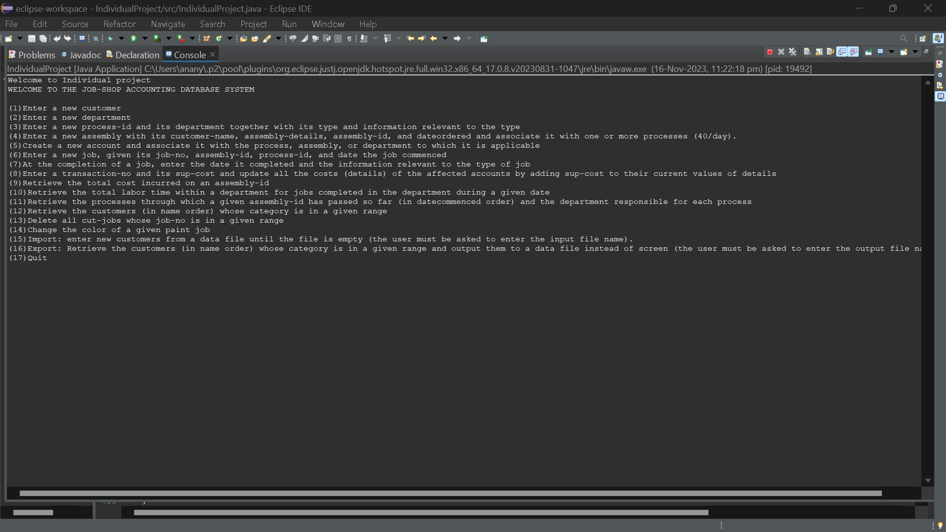

First query:

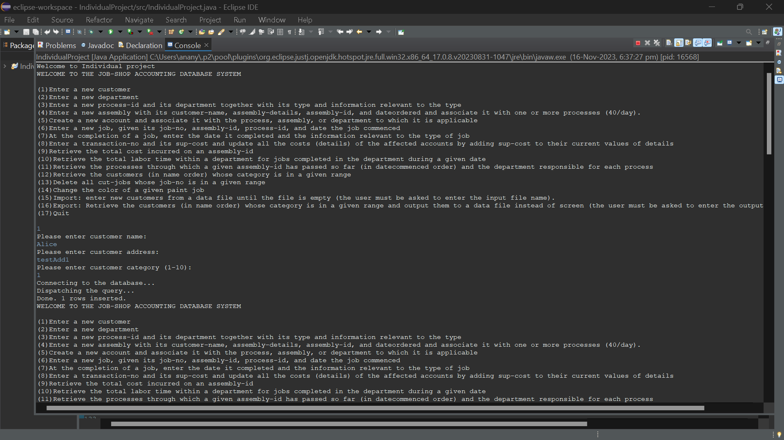

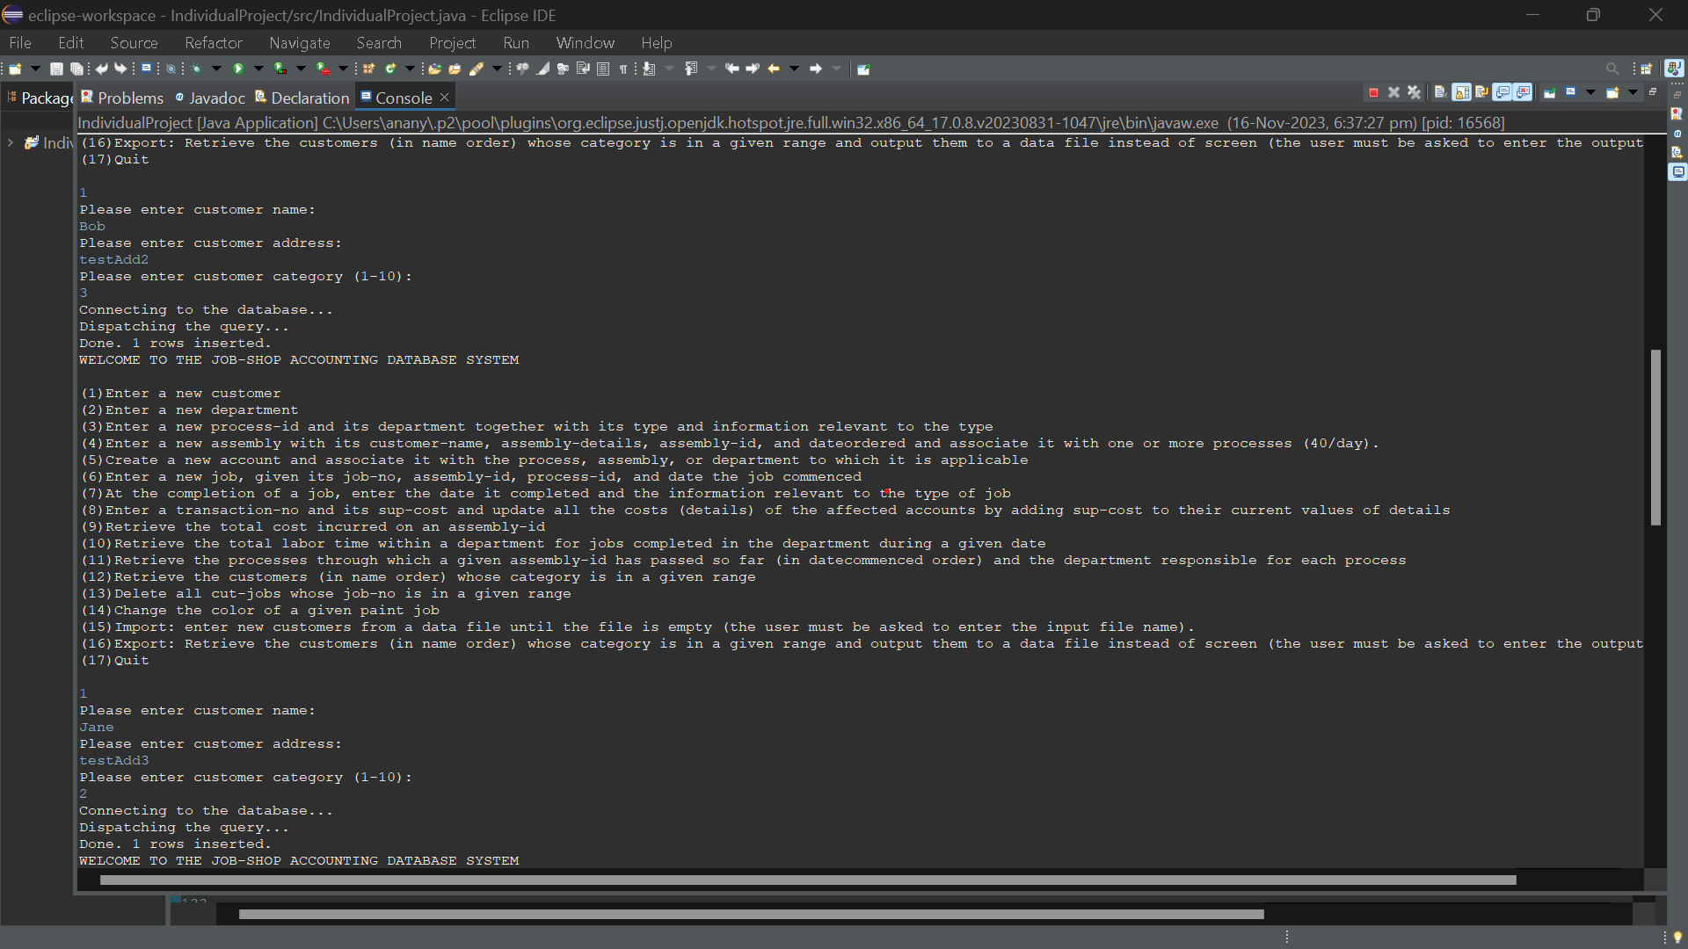

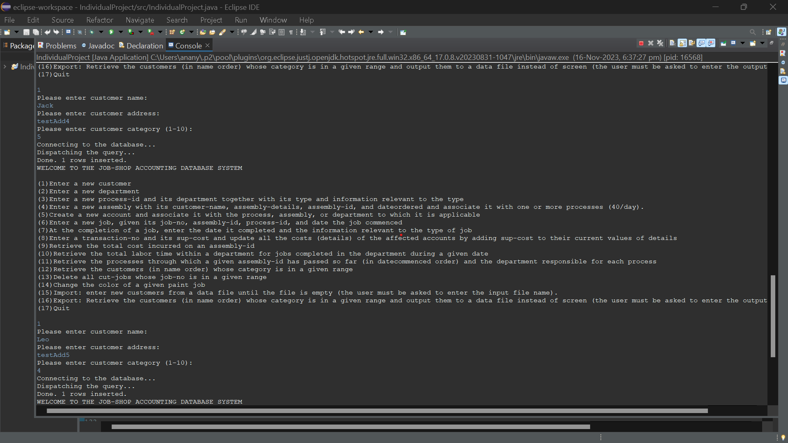

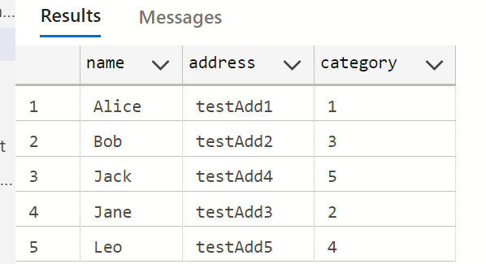

2nd query:

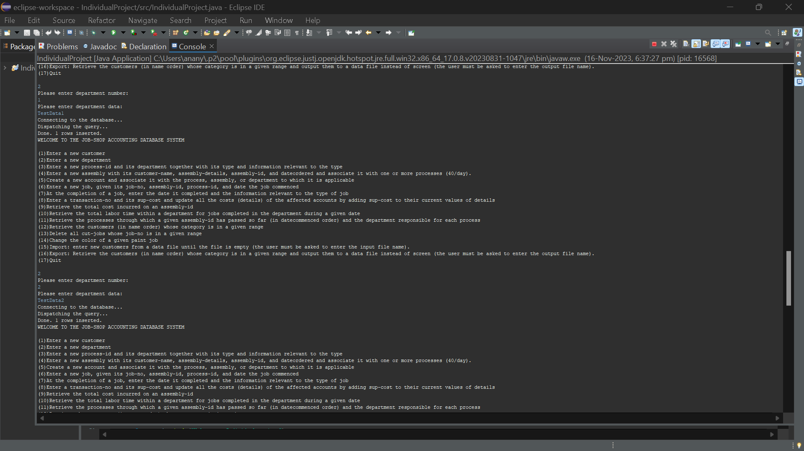

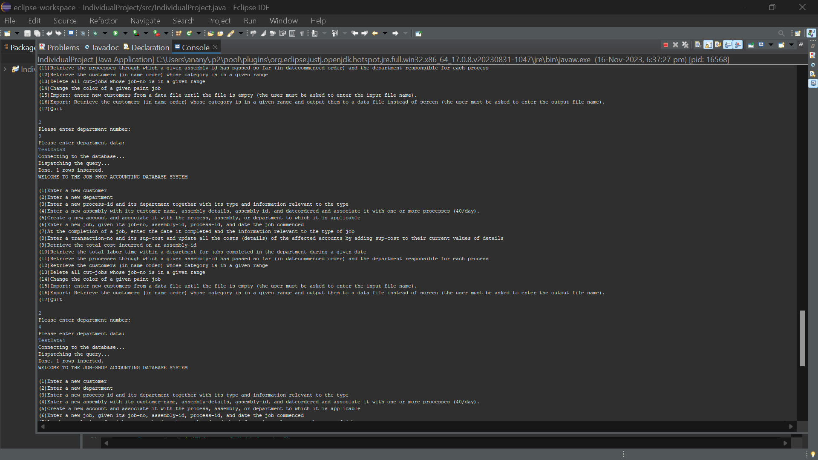

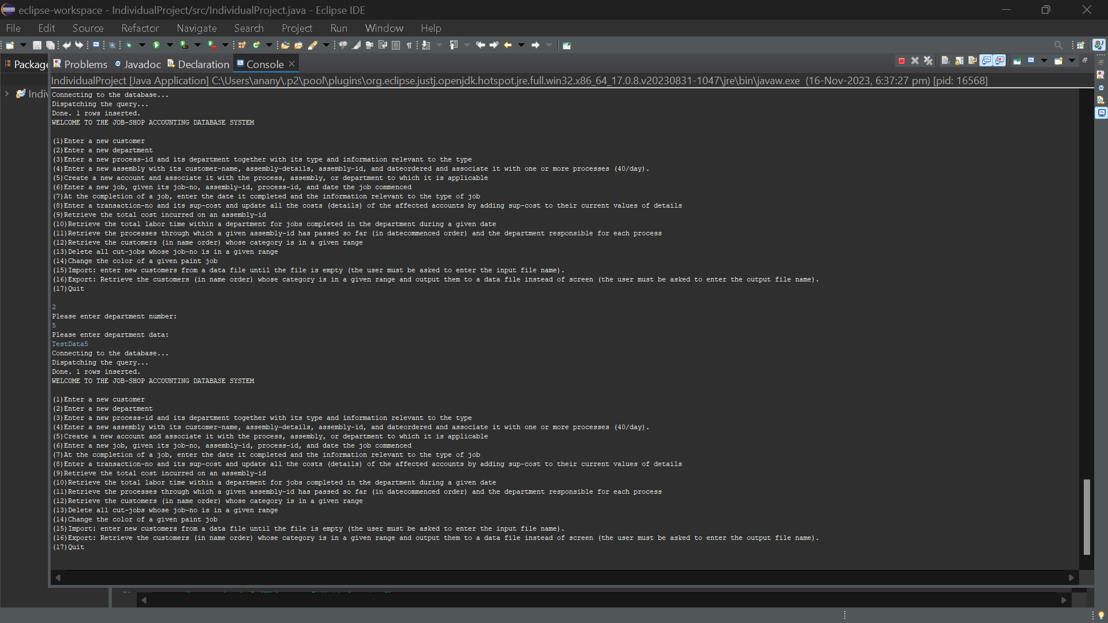

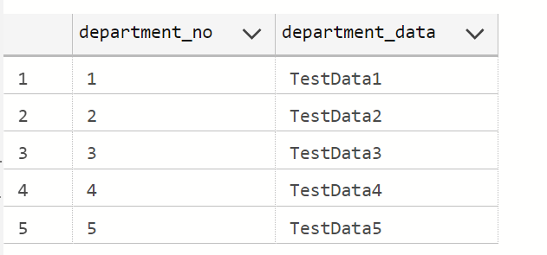

Query 3:

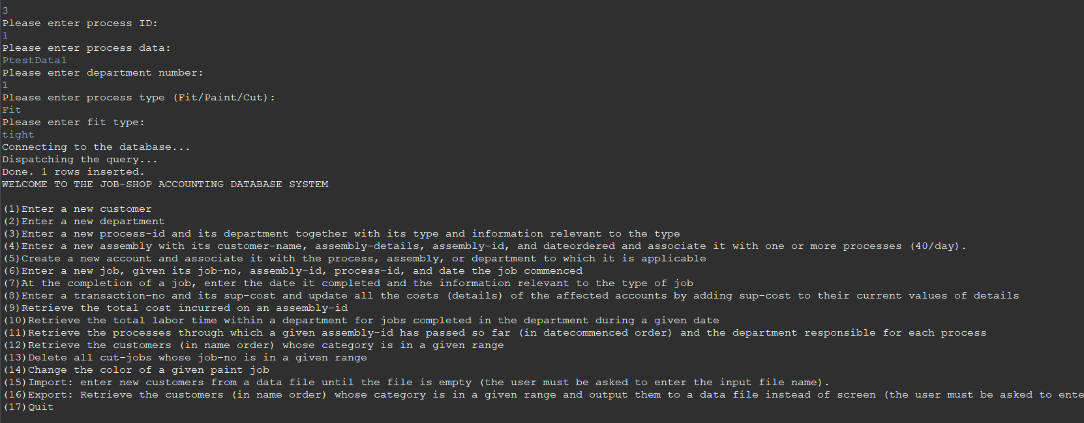

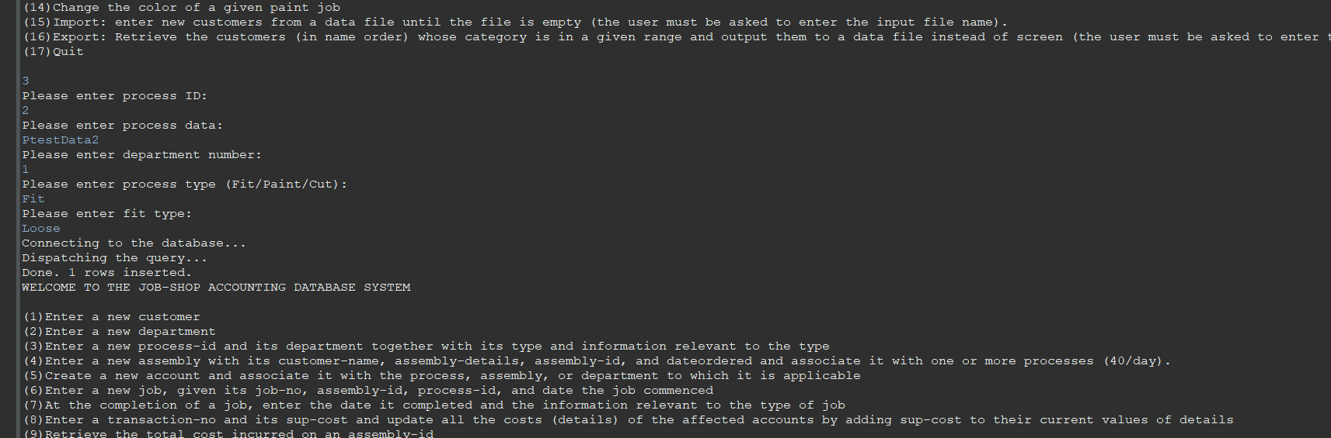

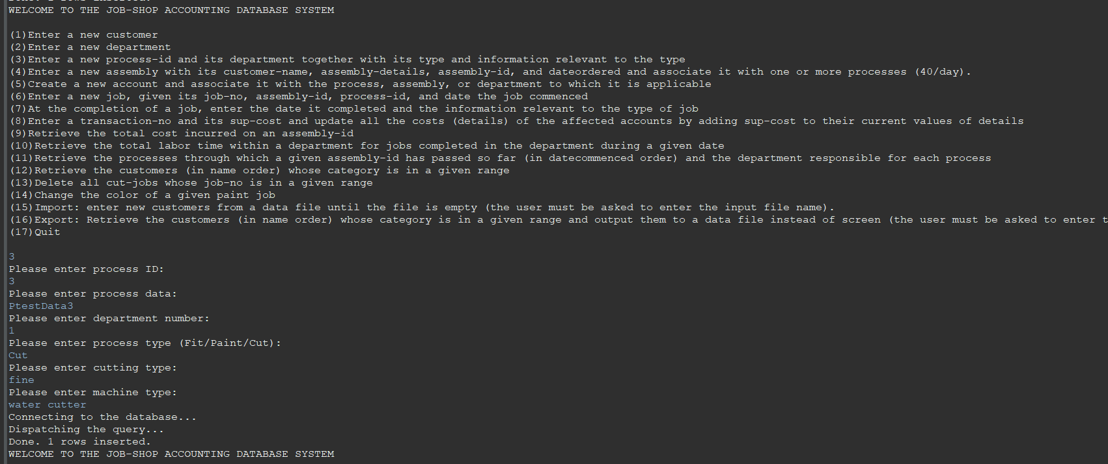

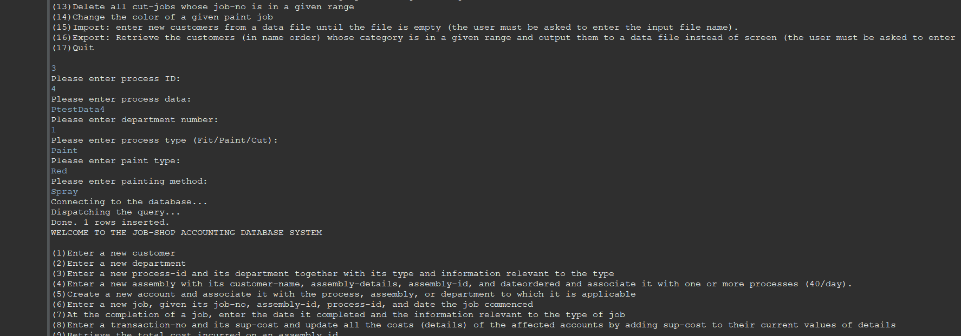

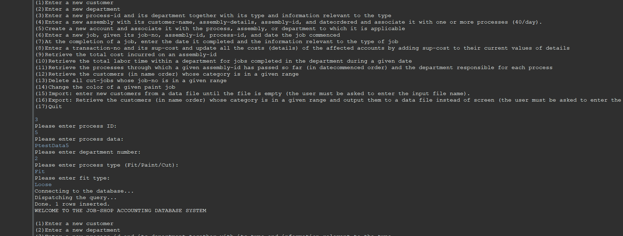

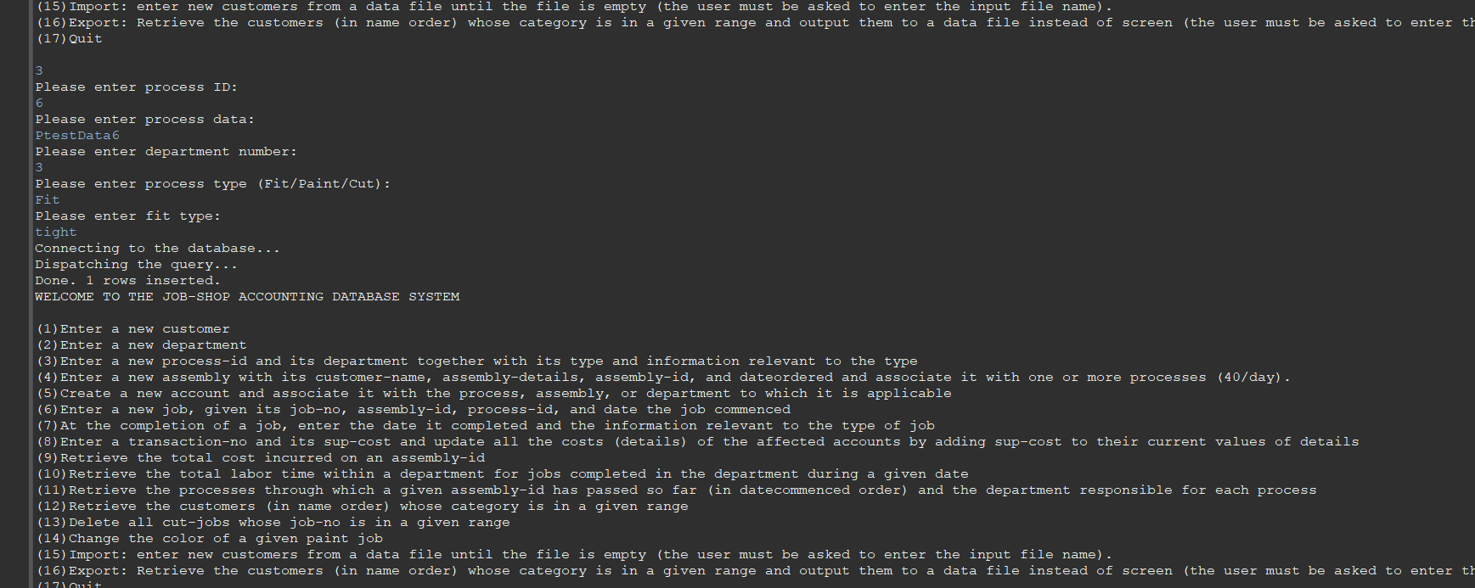

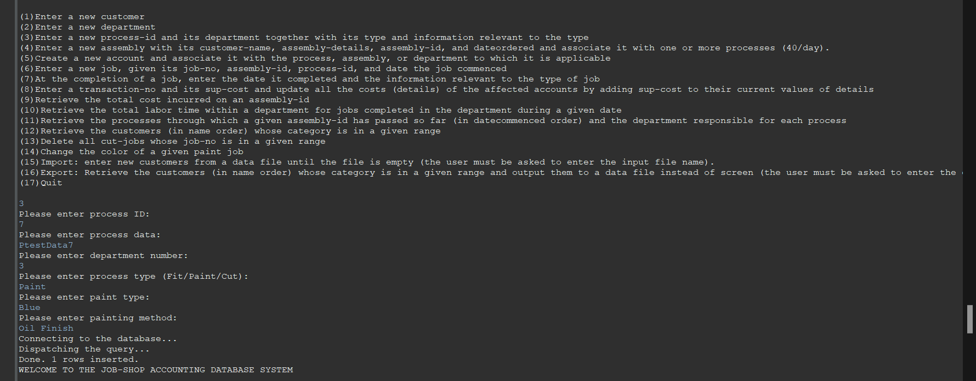

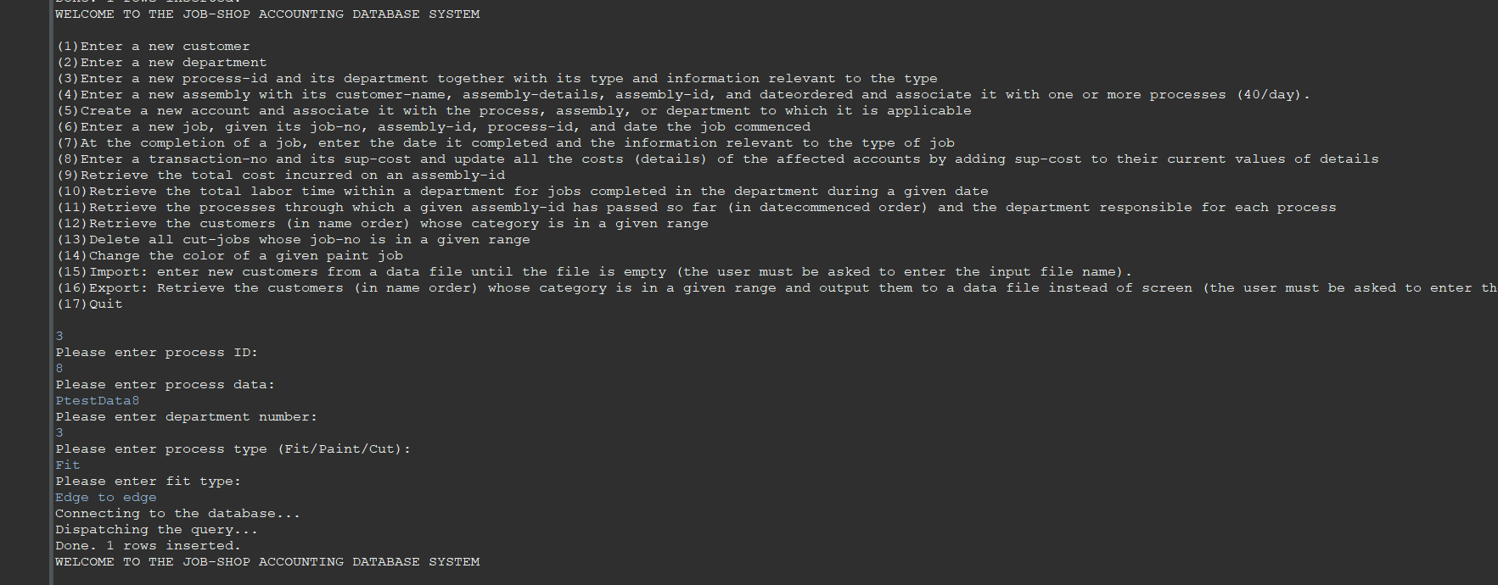

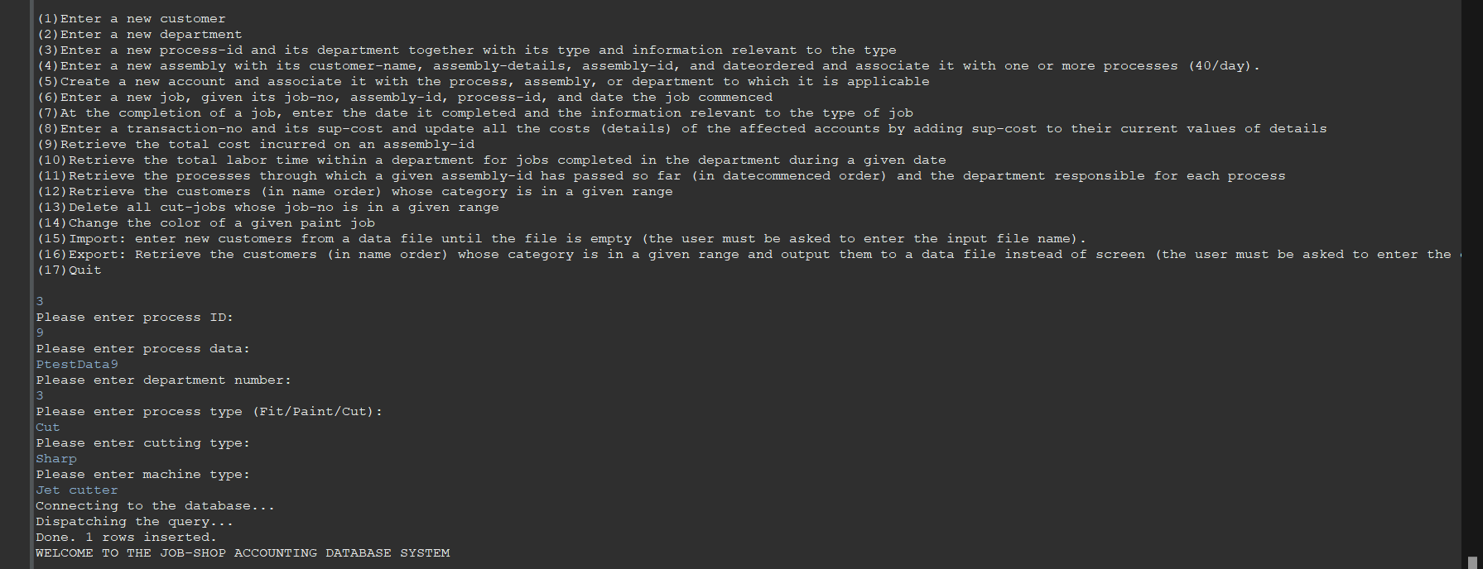

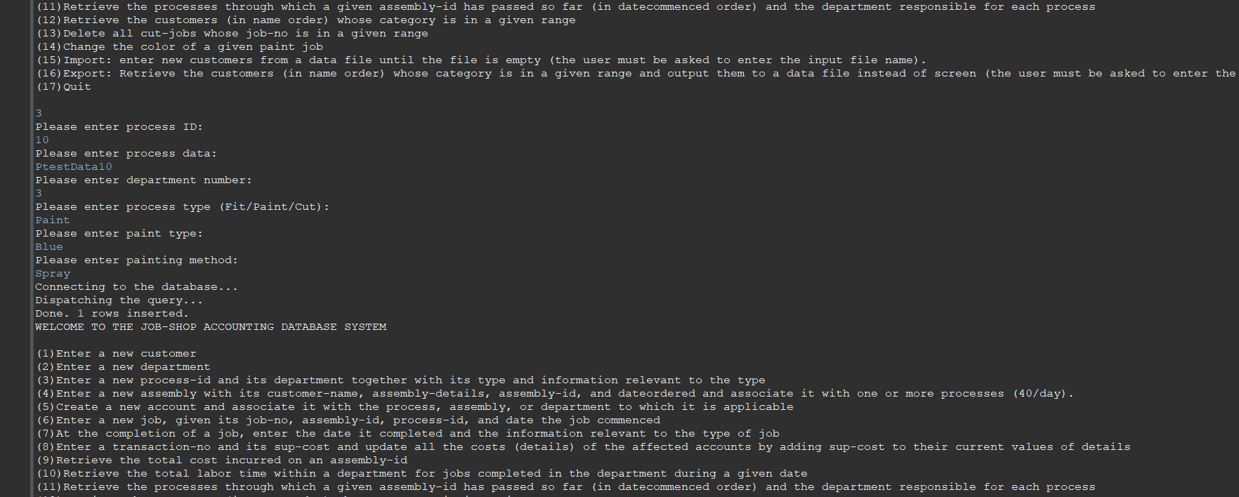

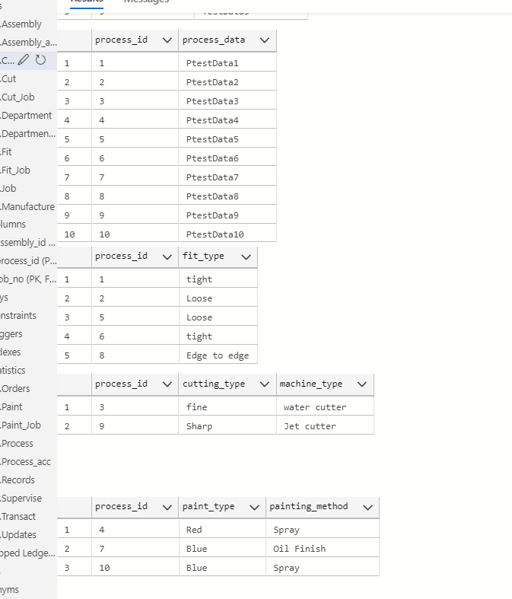

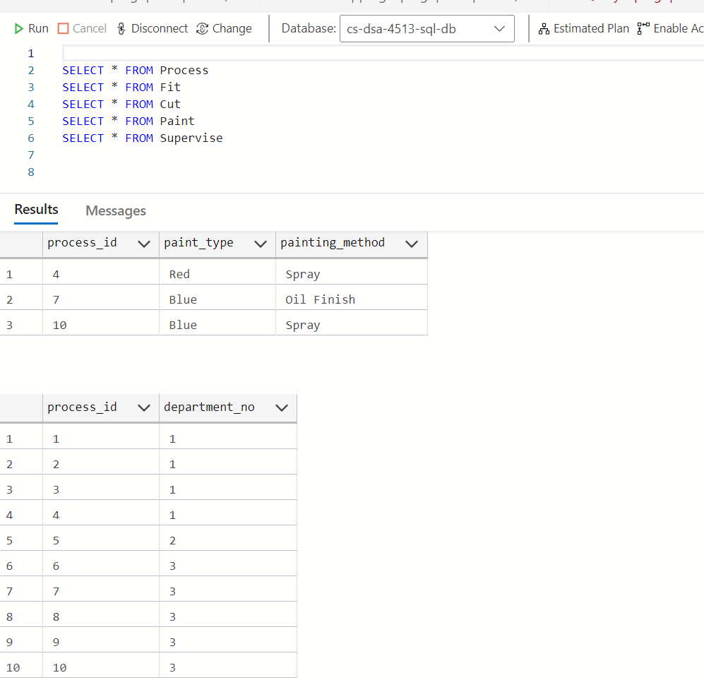

Query 4:

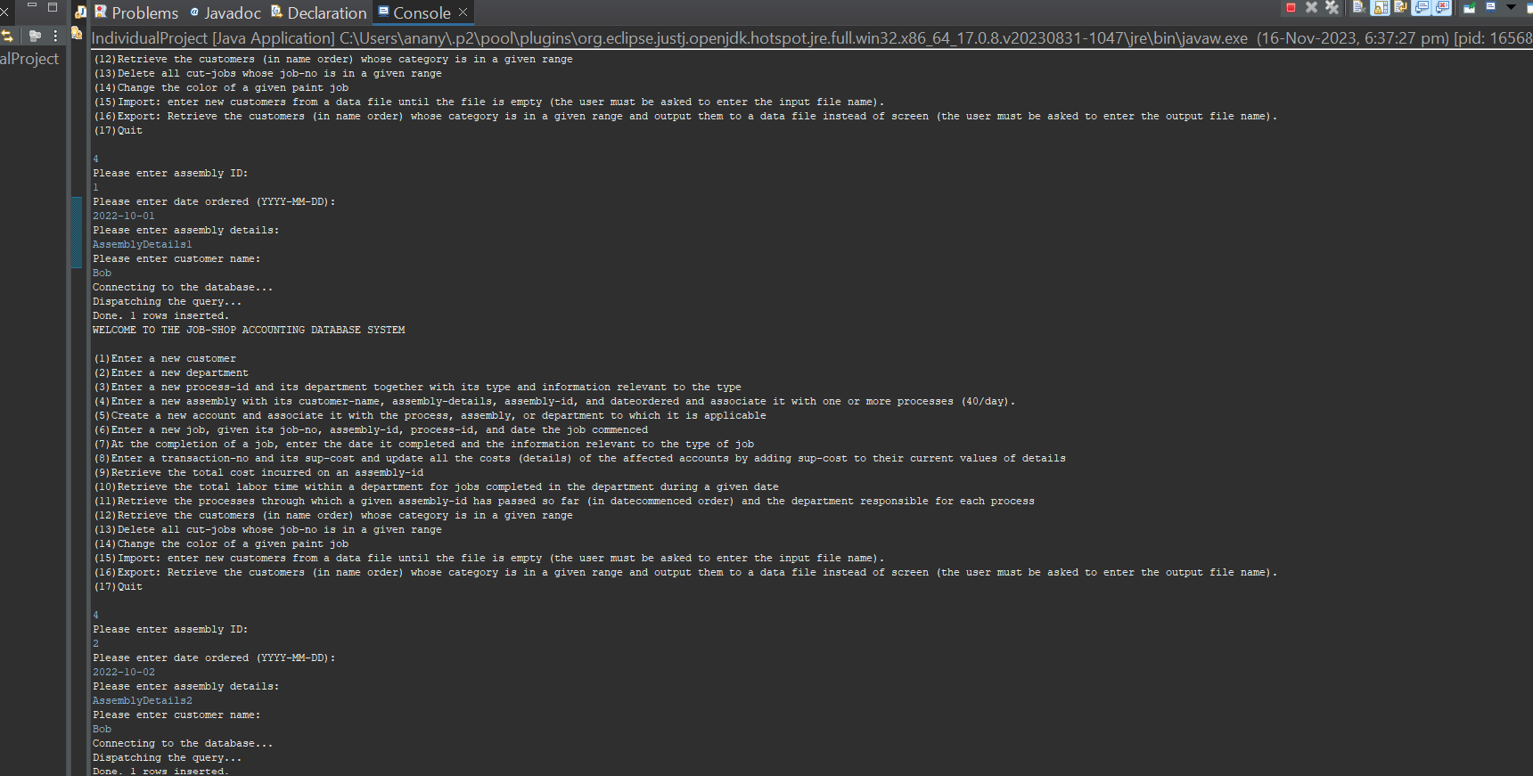

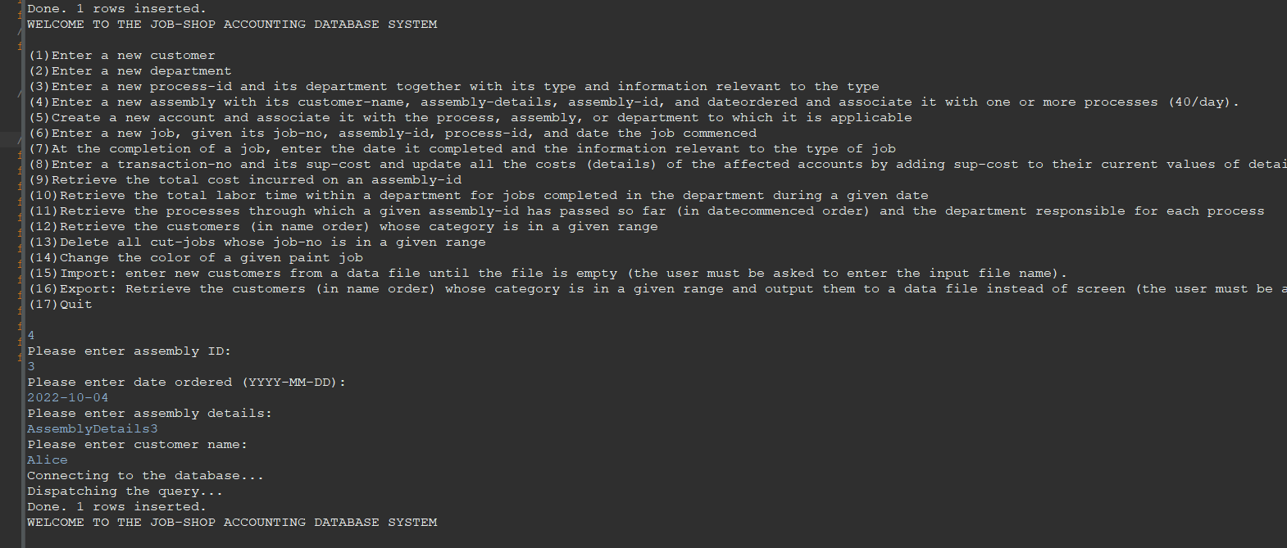

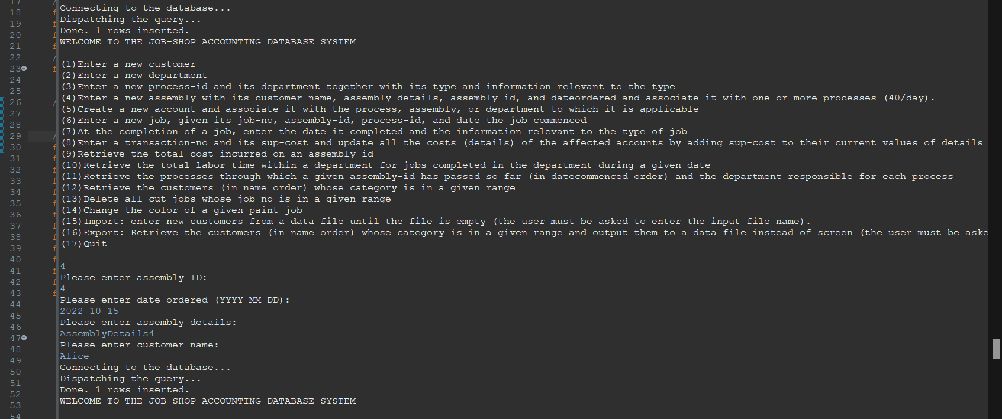

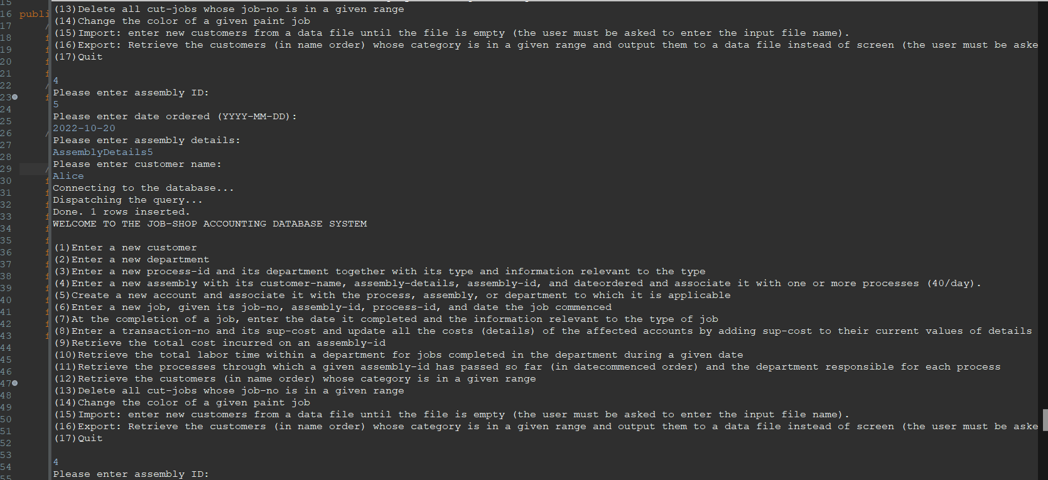

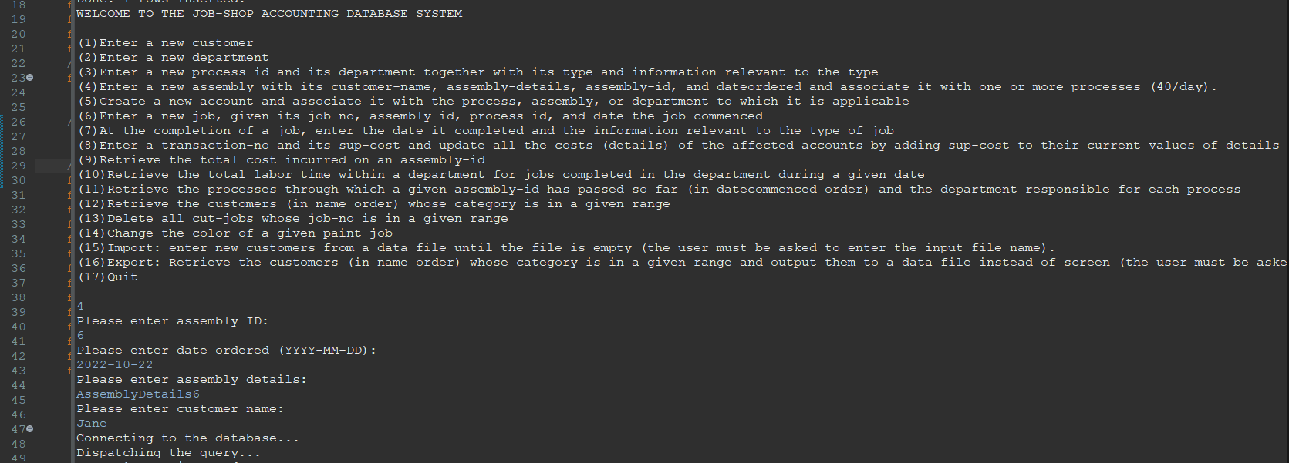

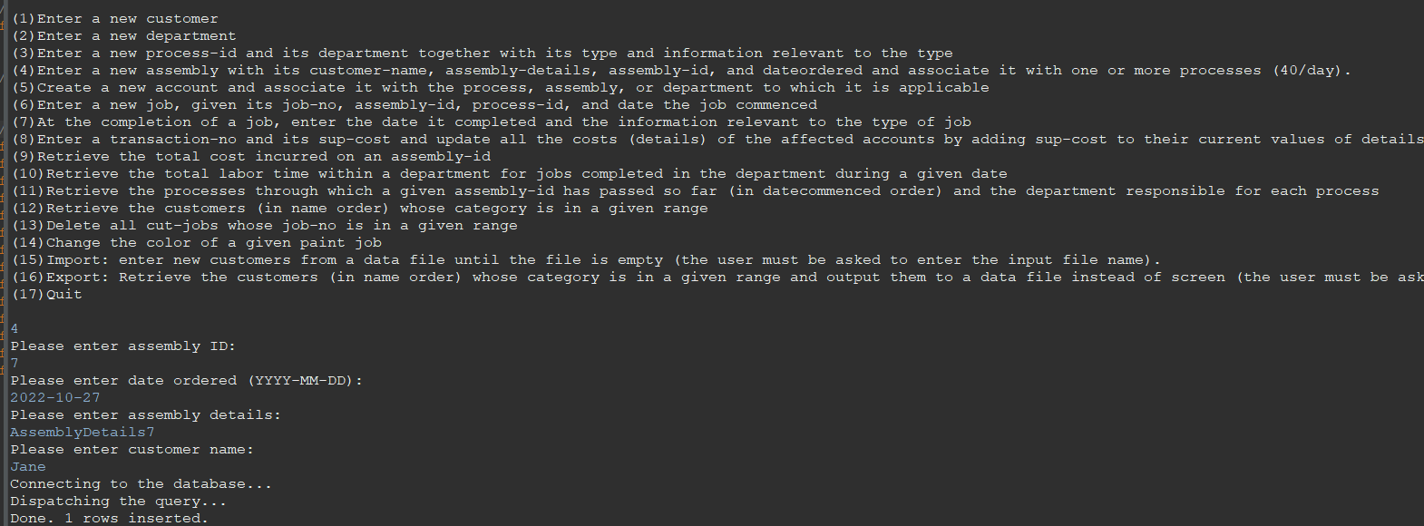

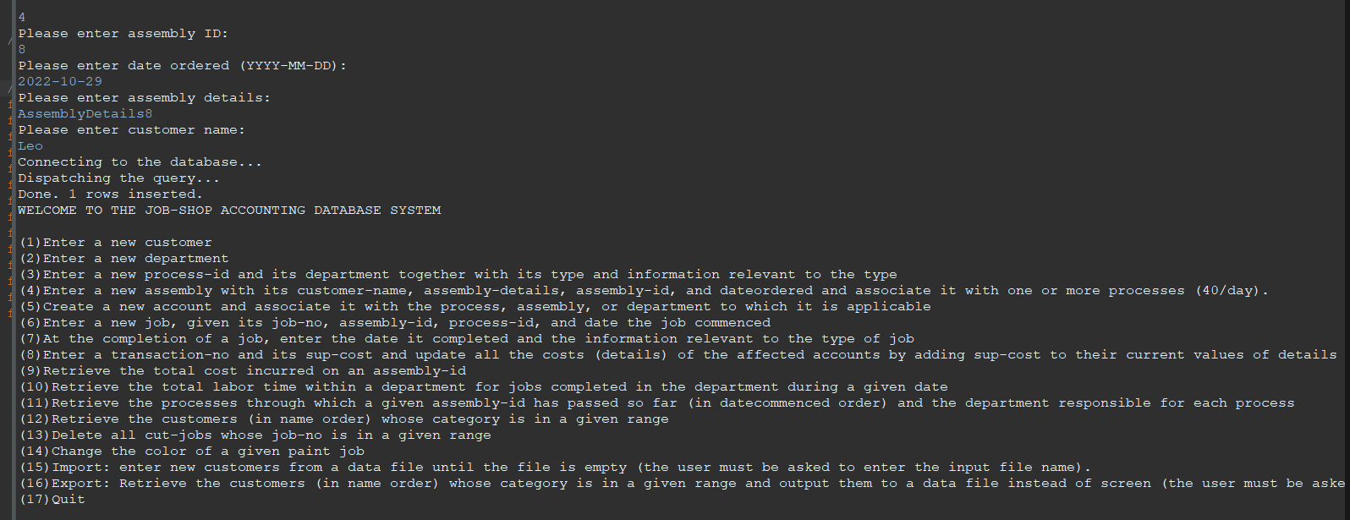

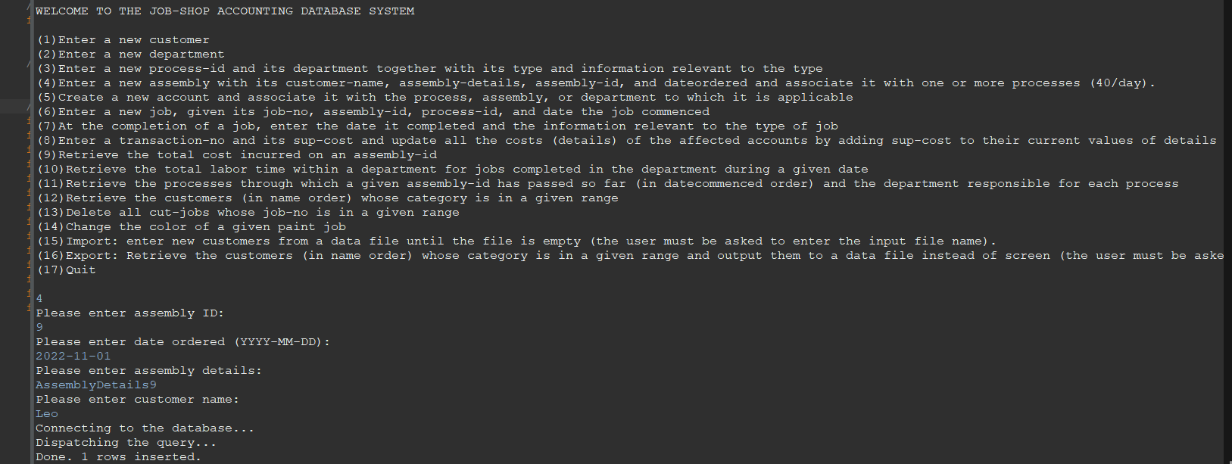

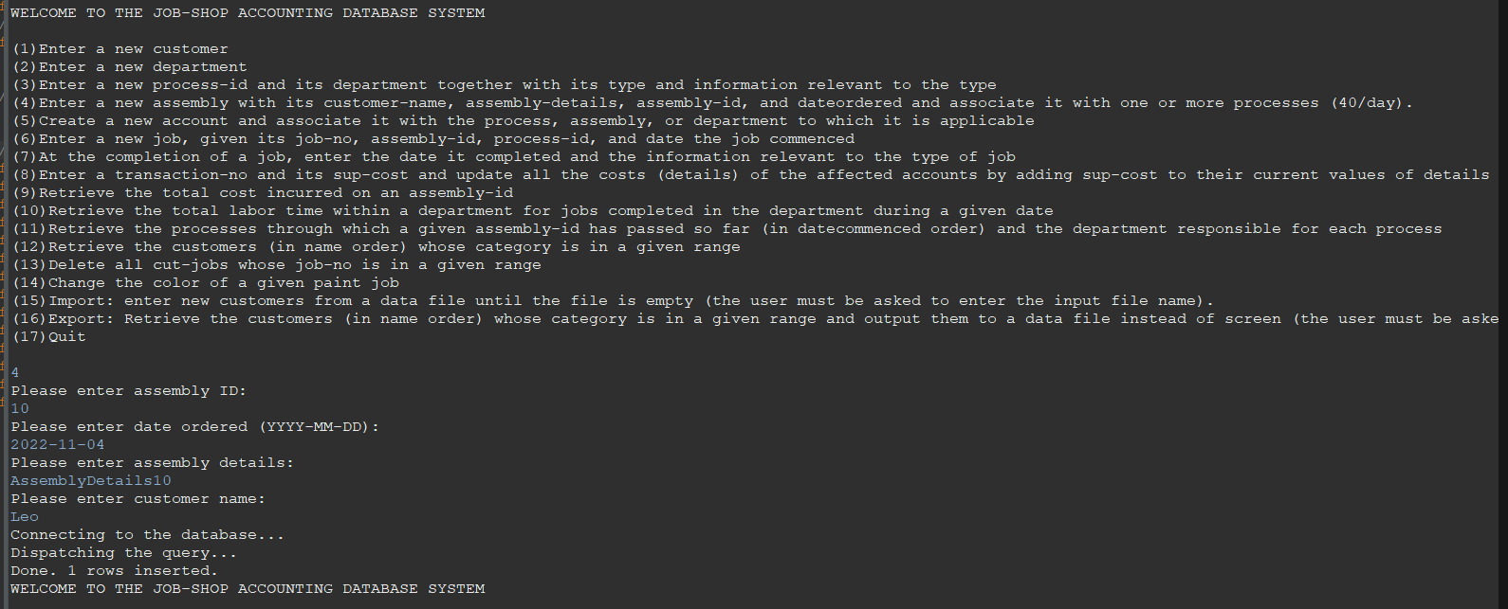

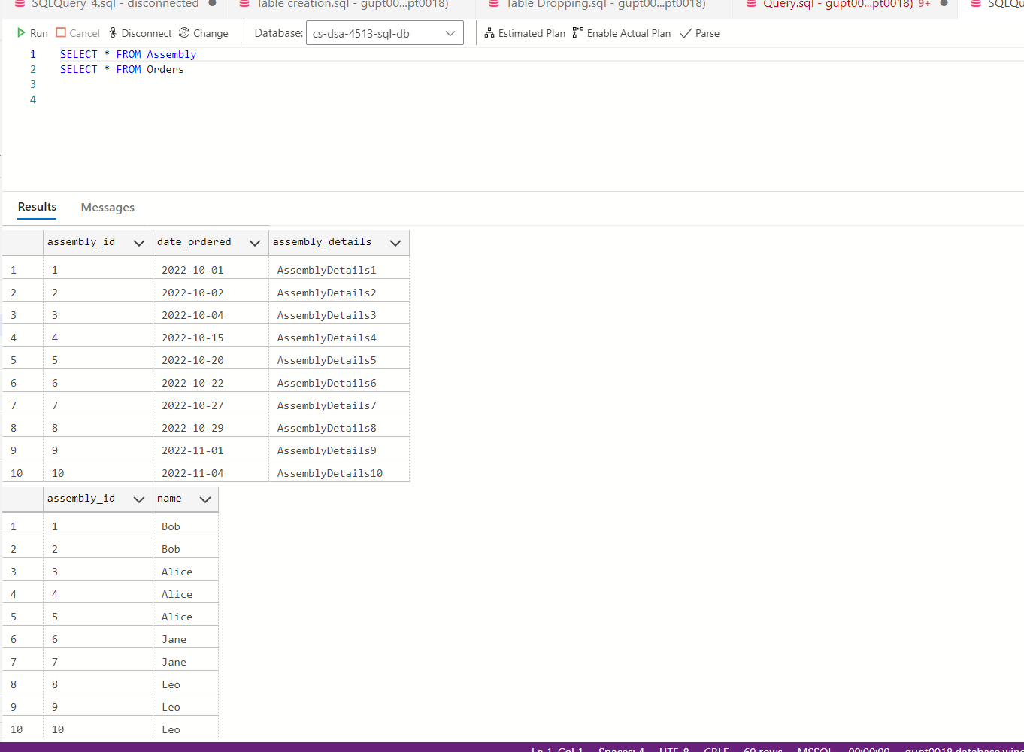

Query 5:

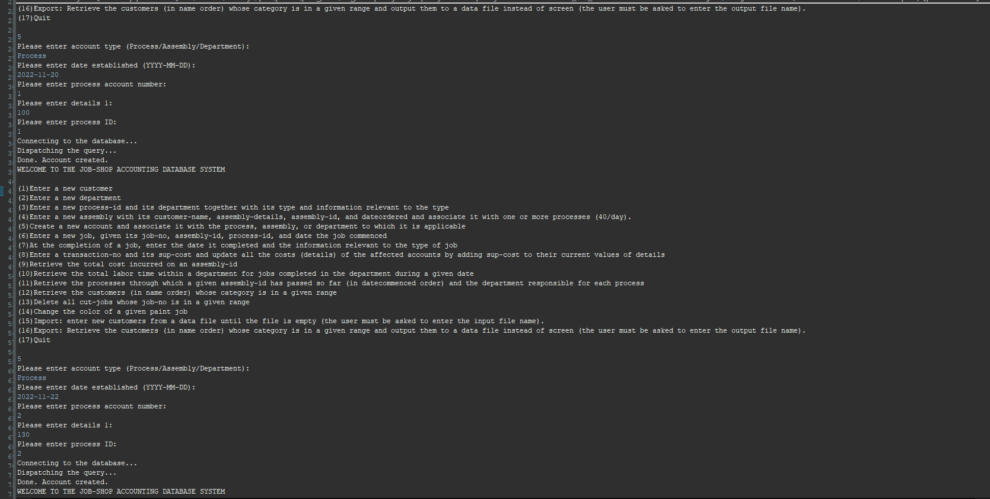

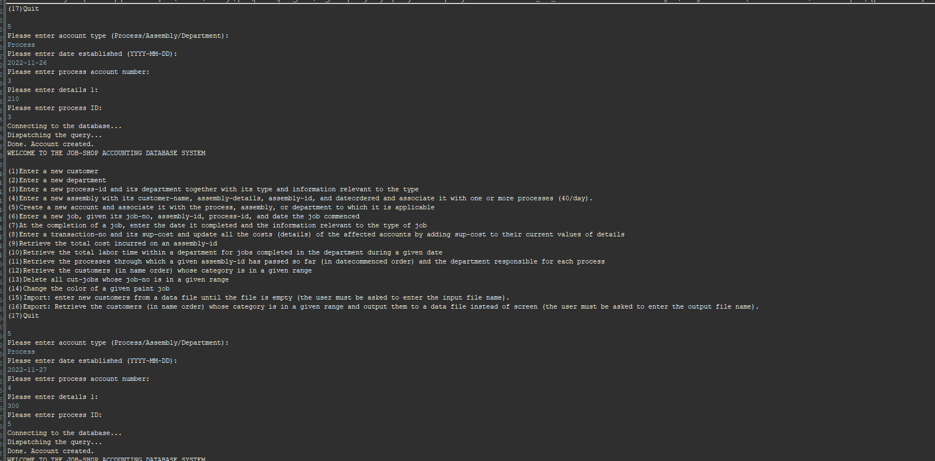

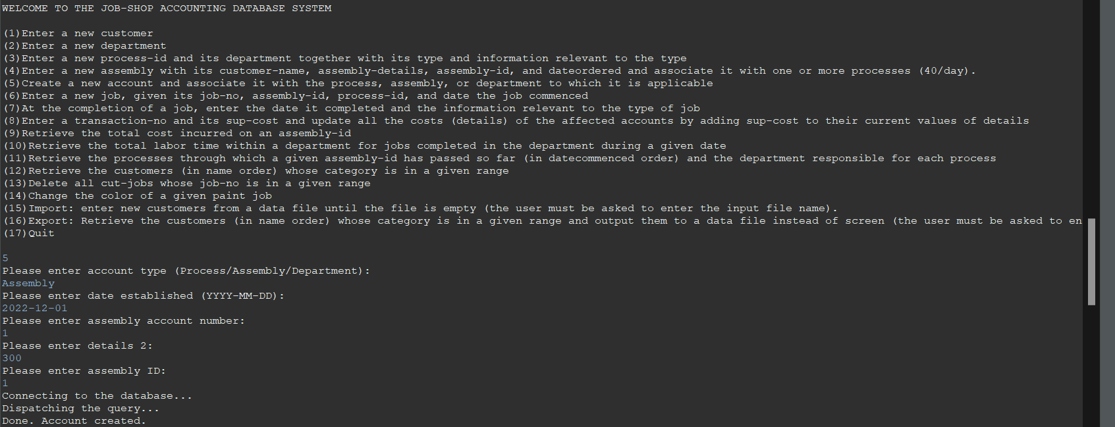

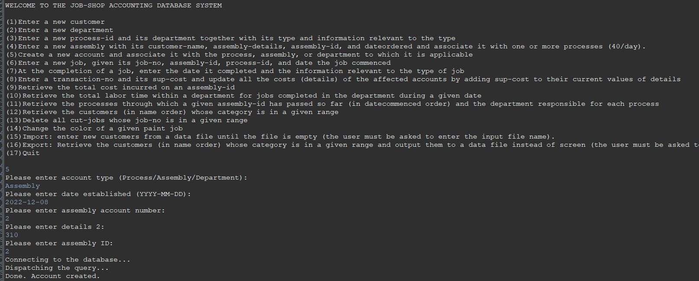

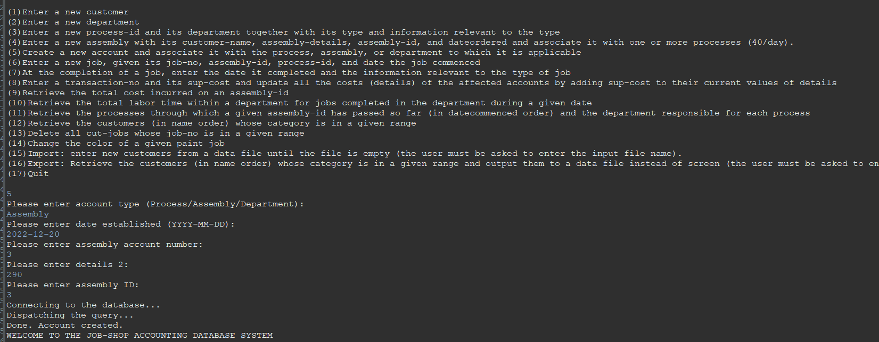

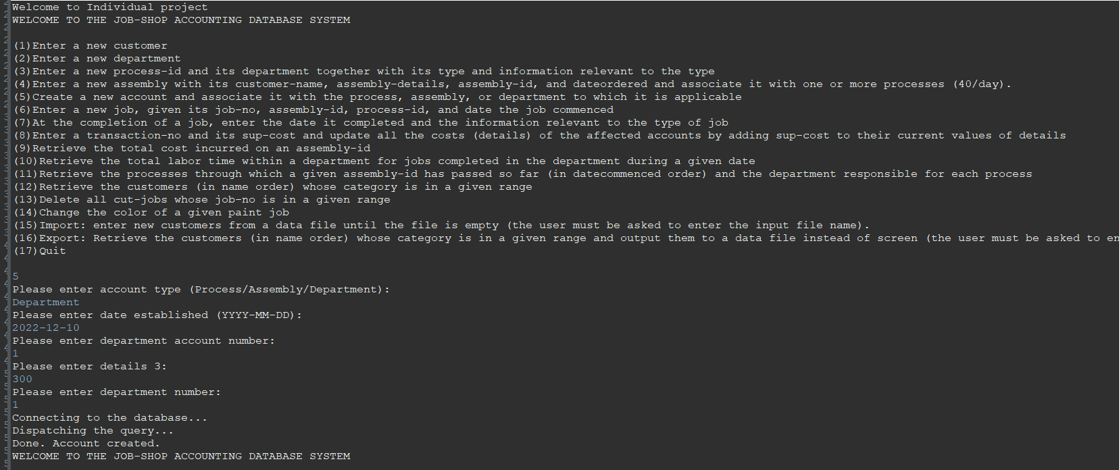

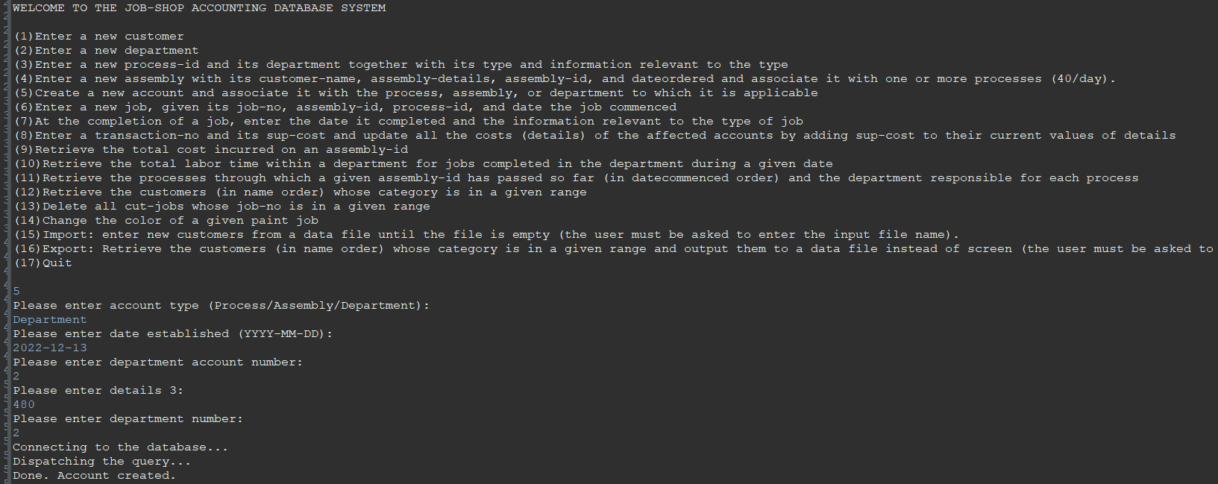

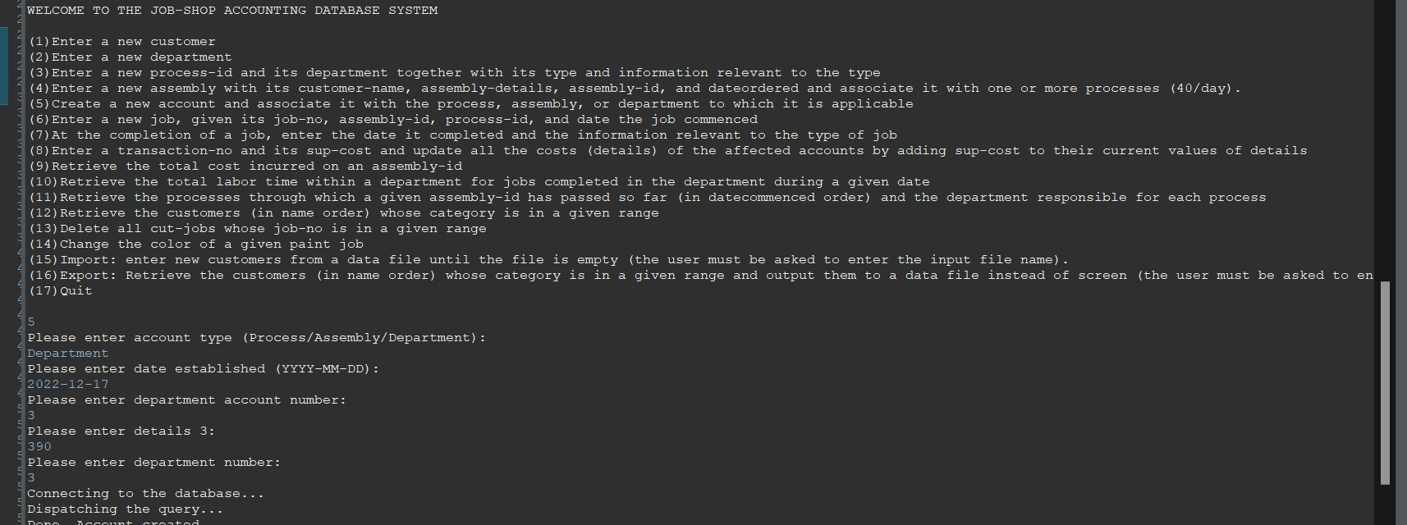

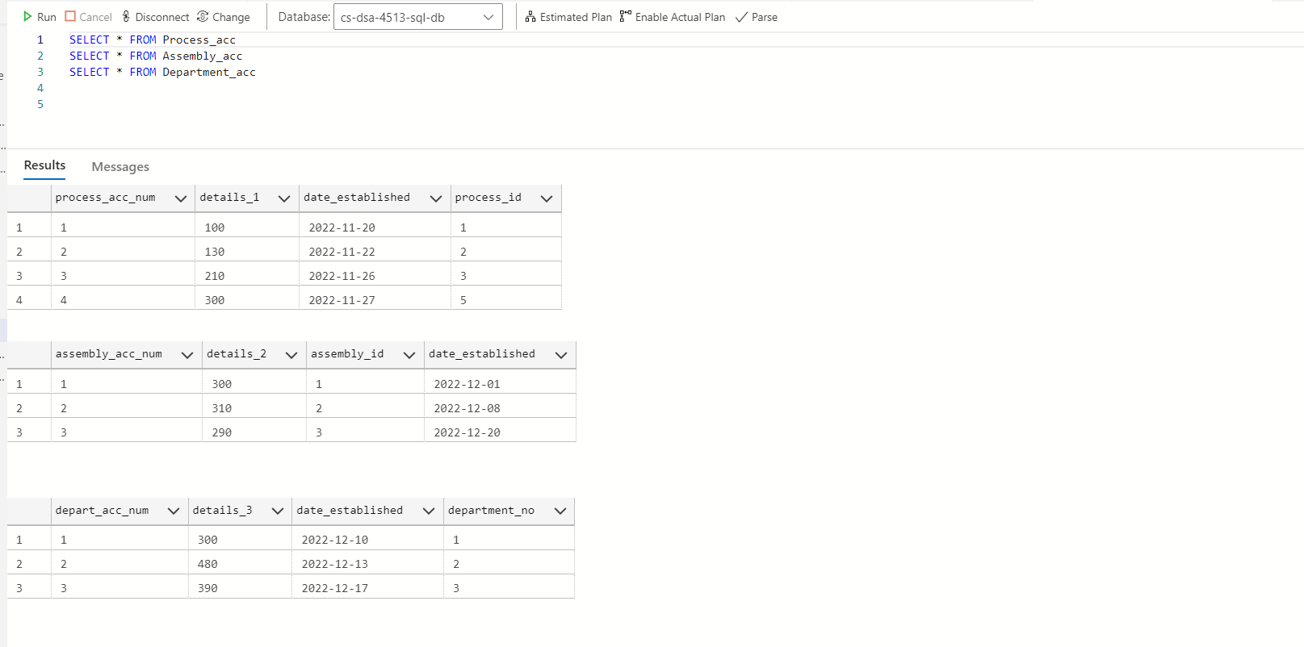

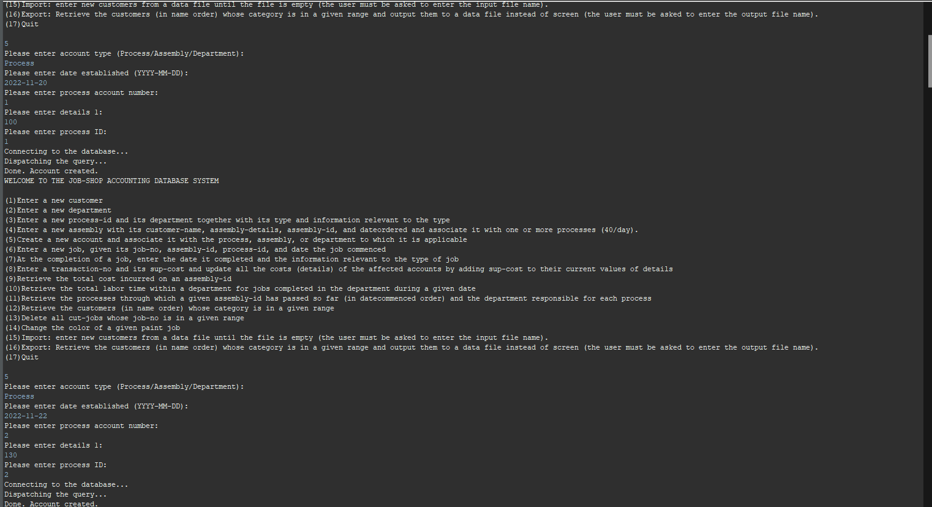

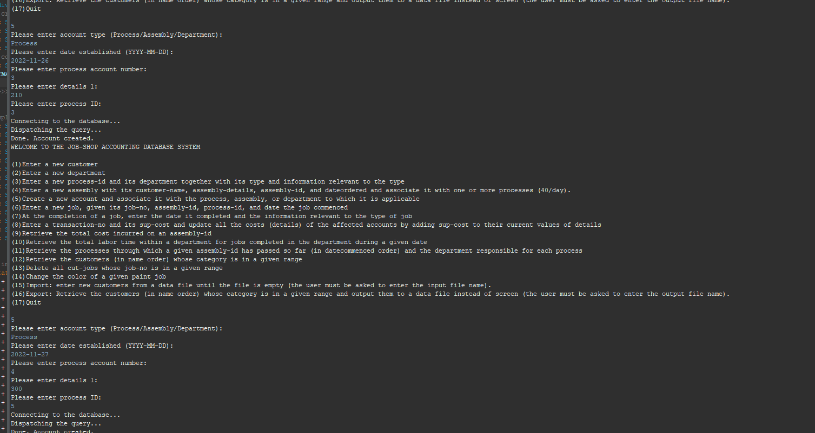

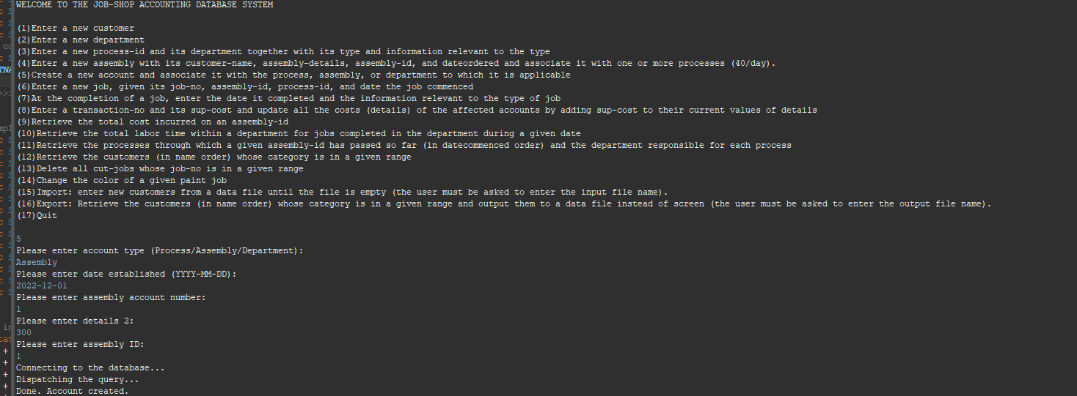

Query 6

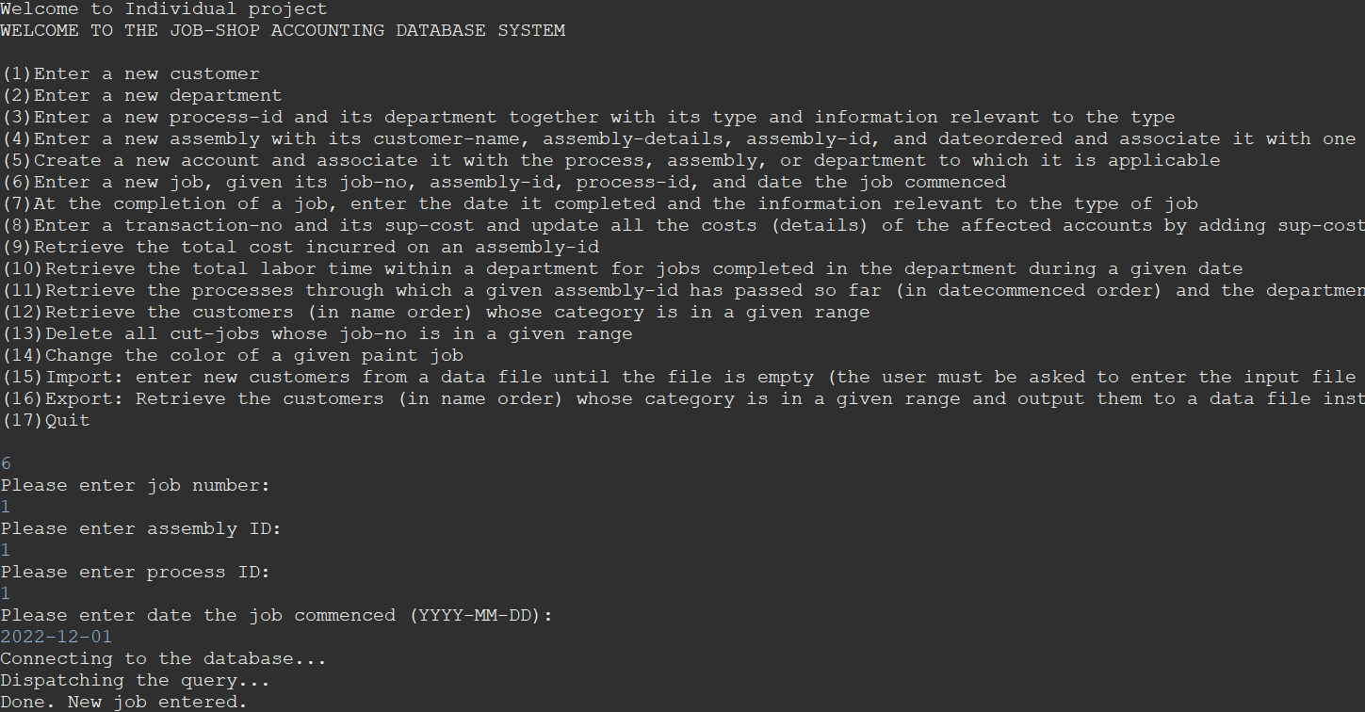

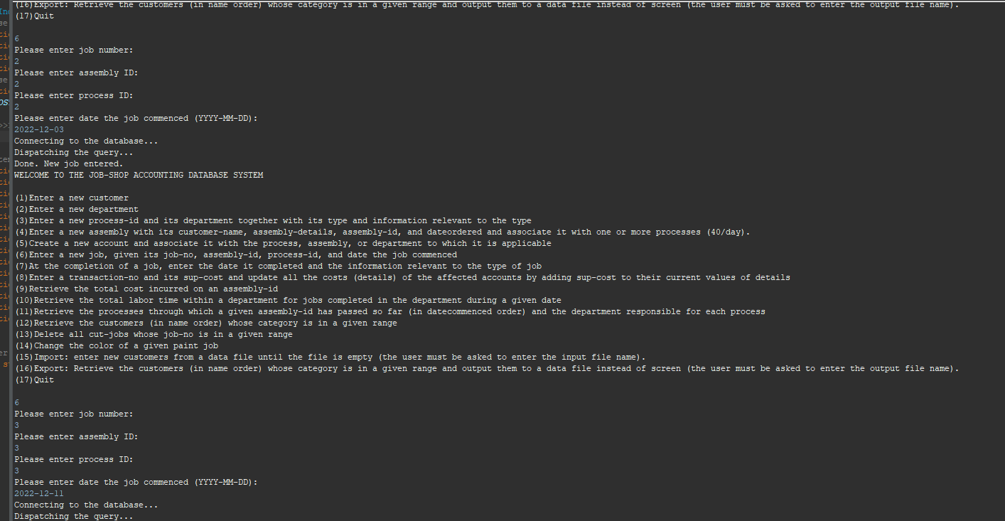

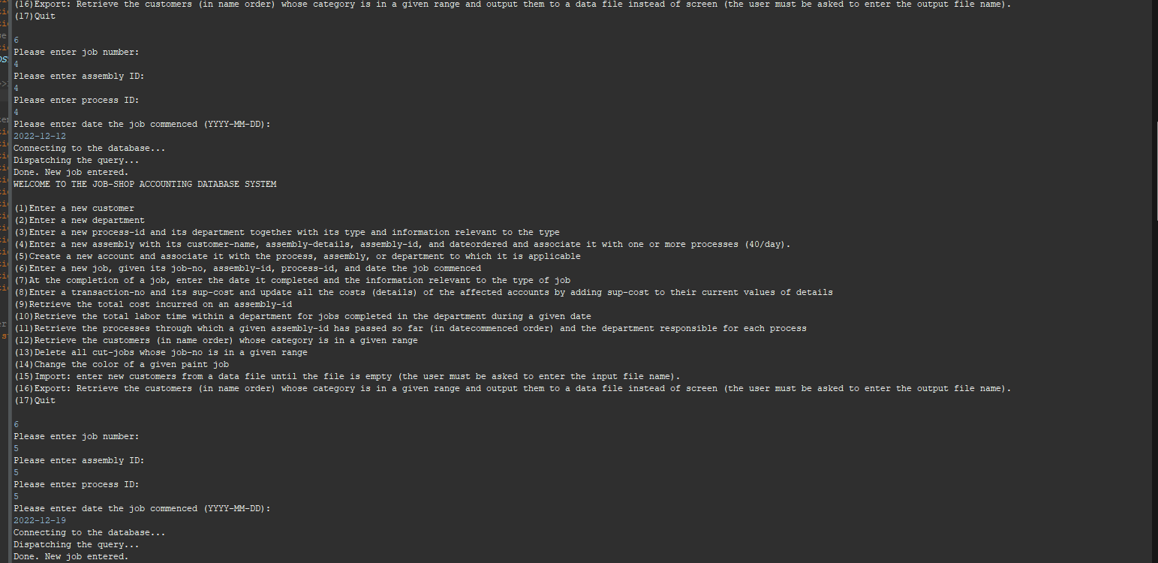

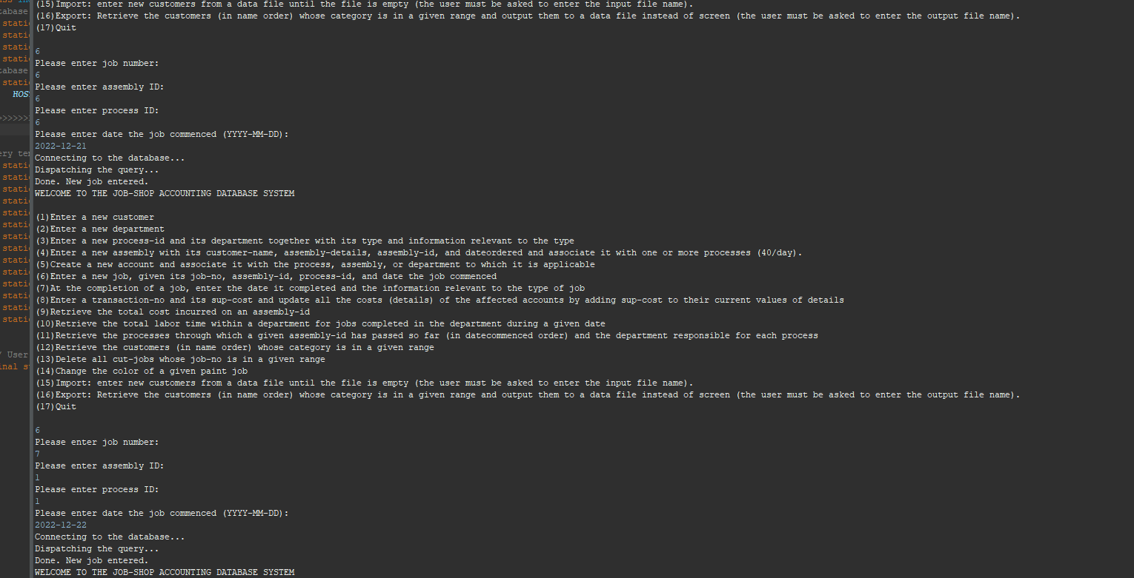

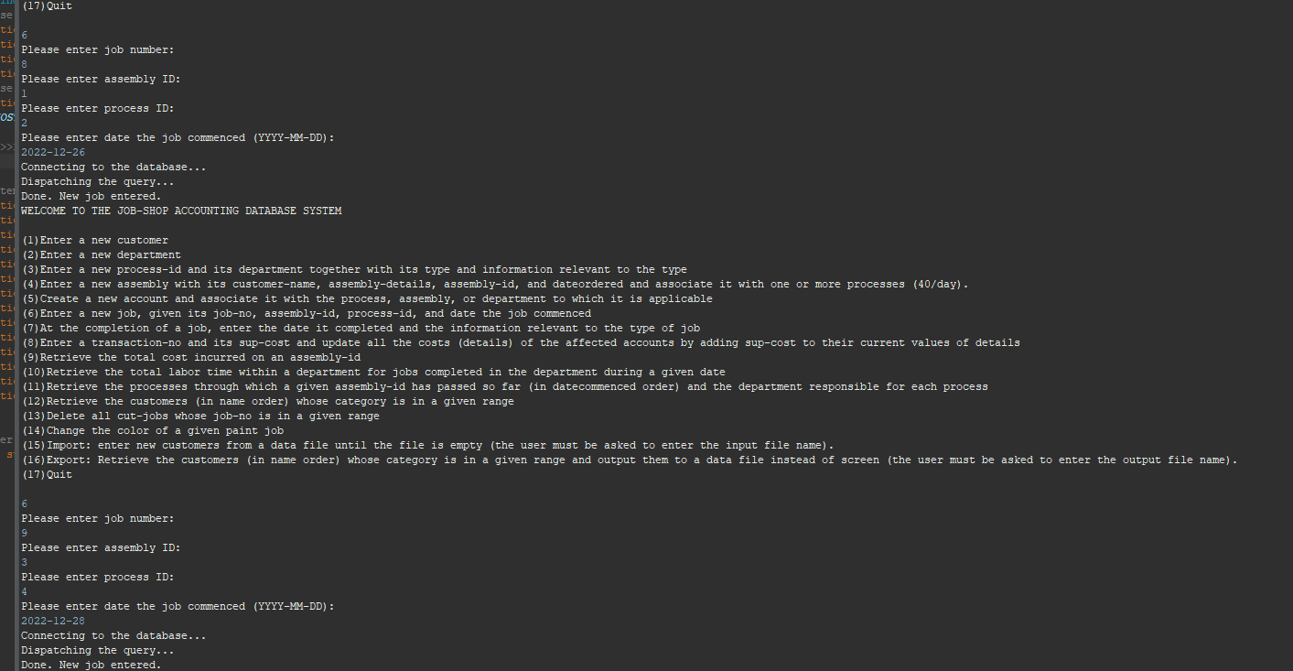

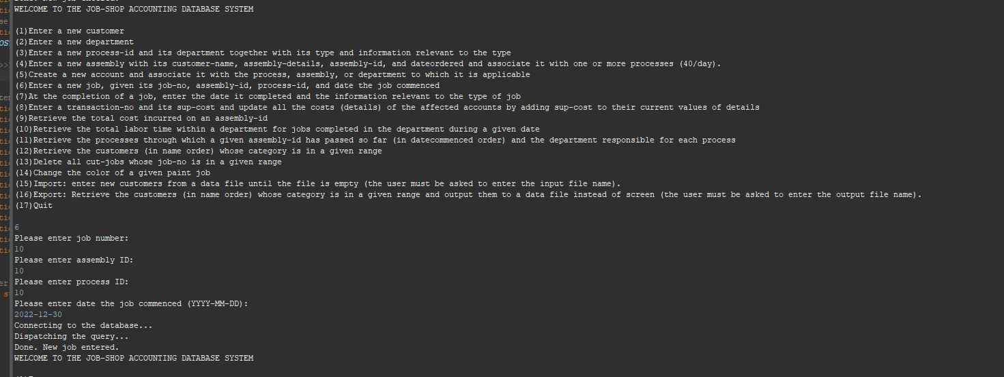

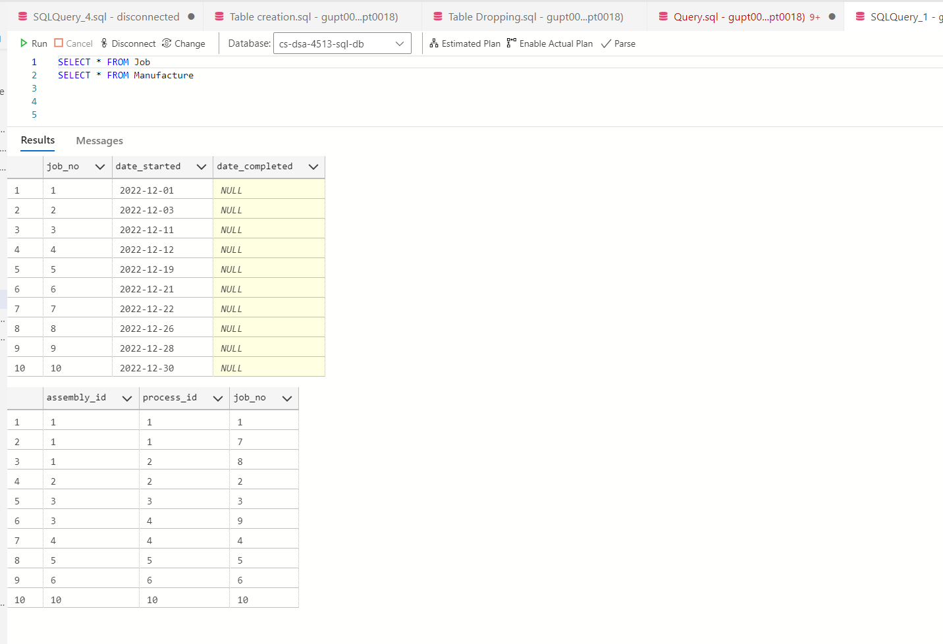

Query 7:

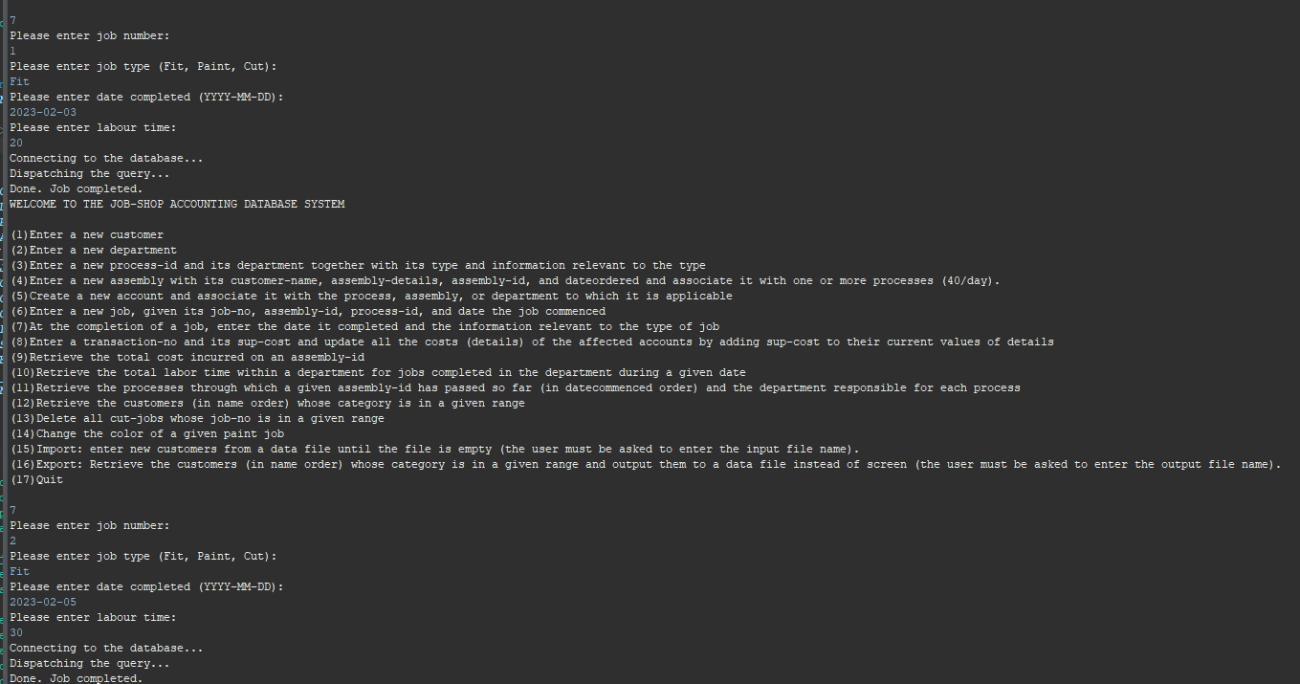

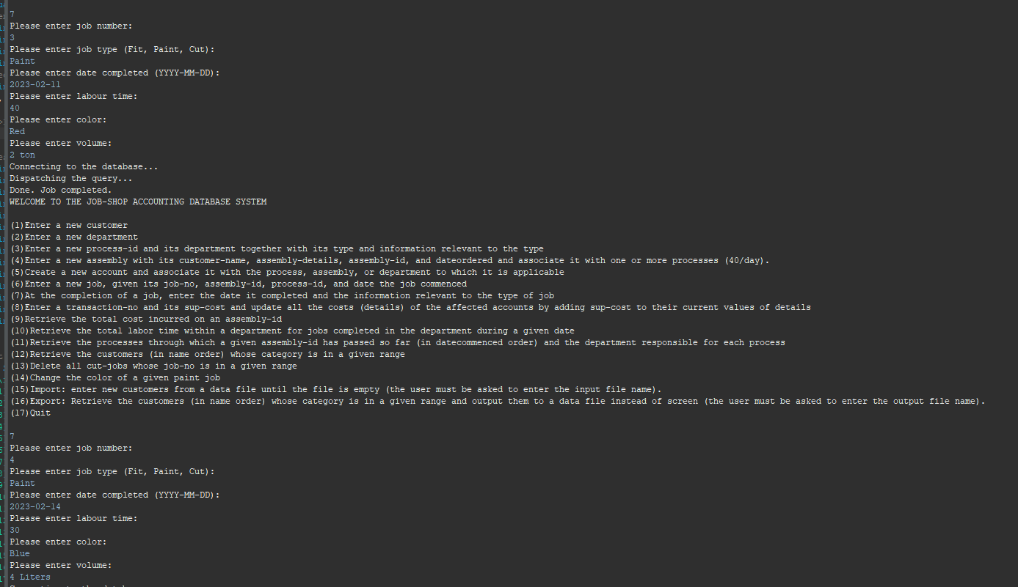

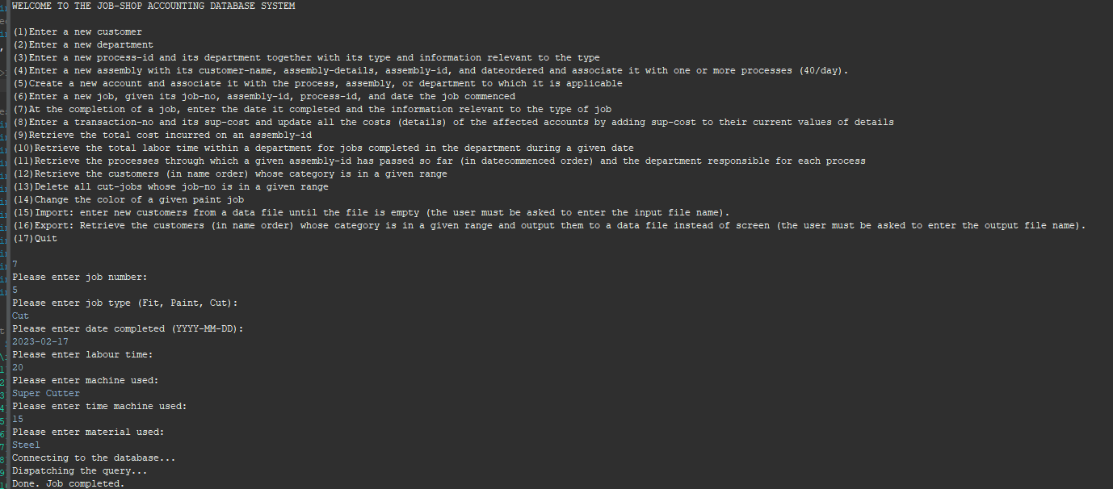

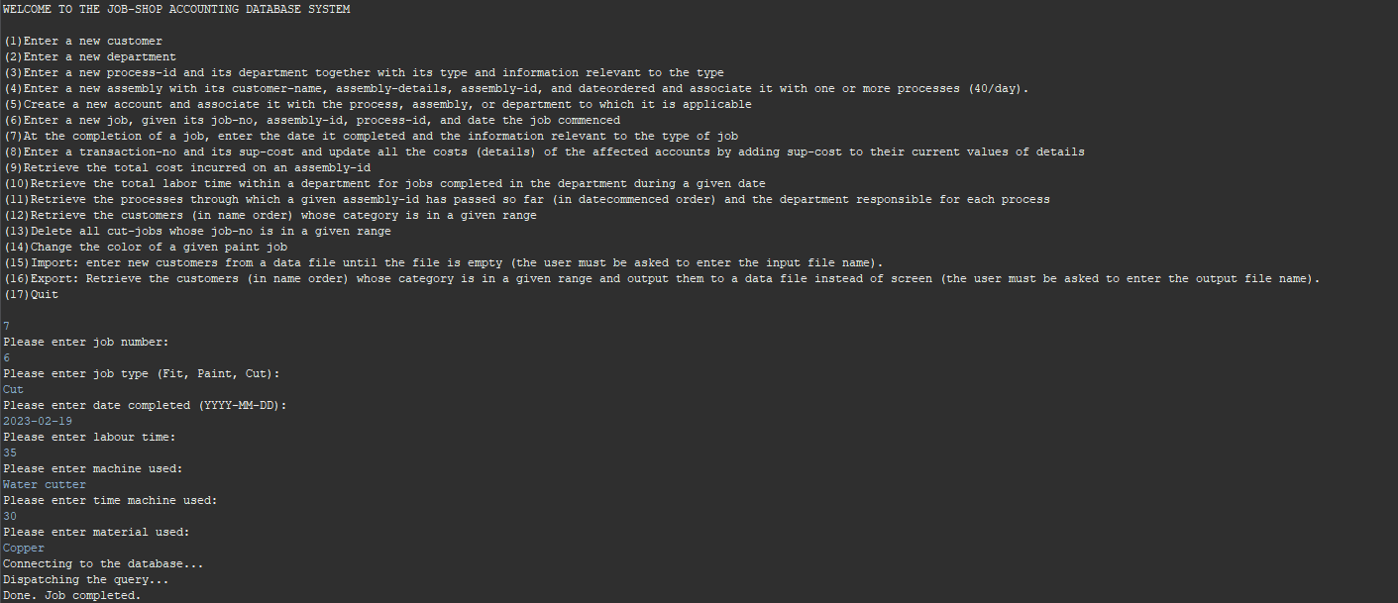

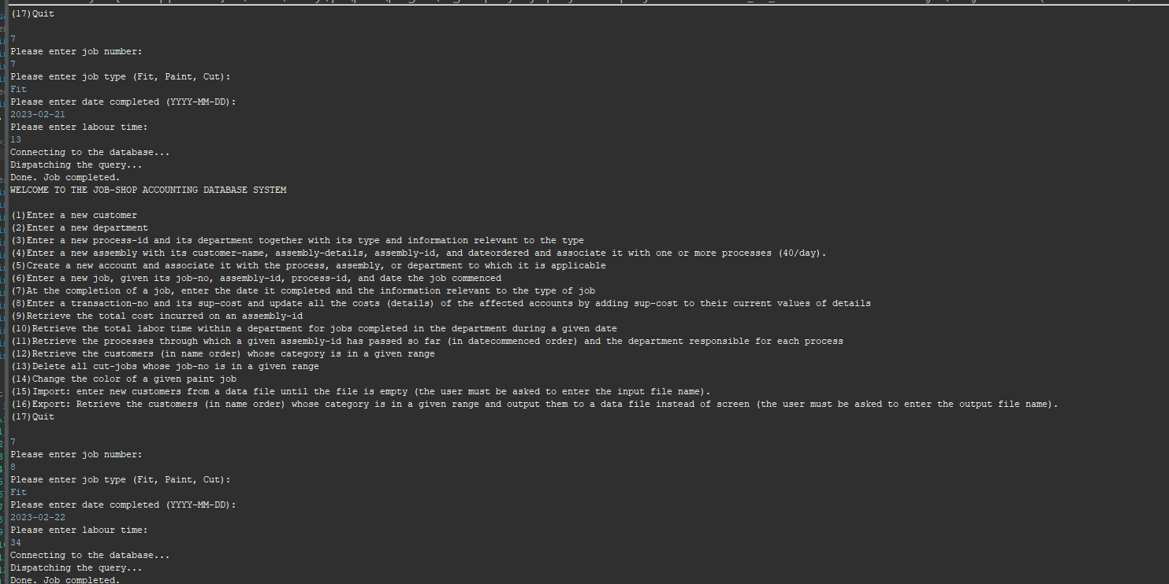

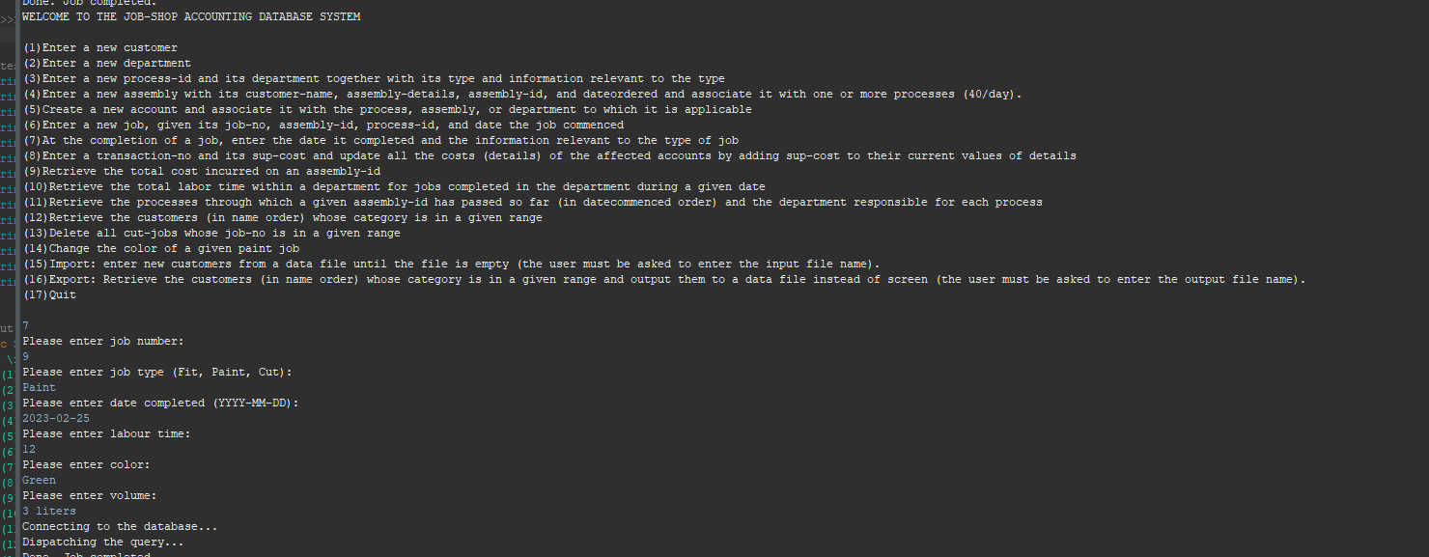

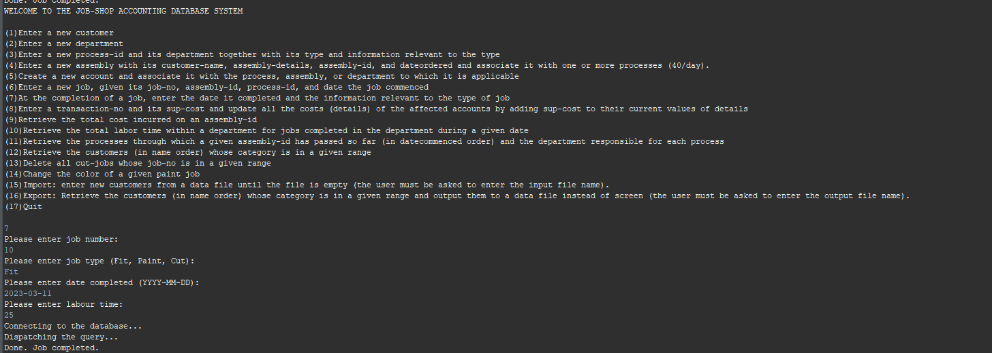

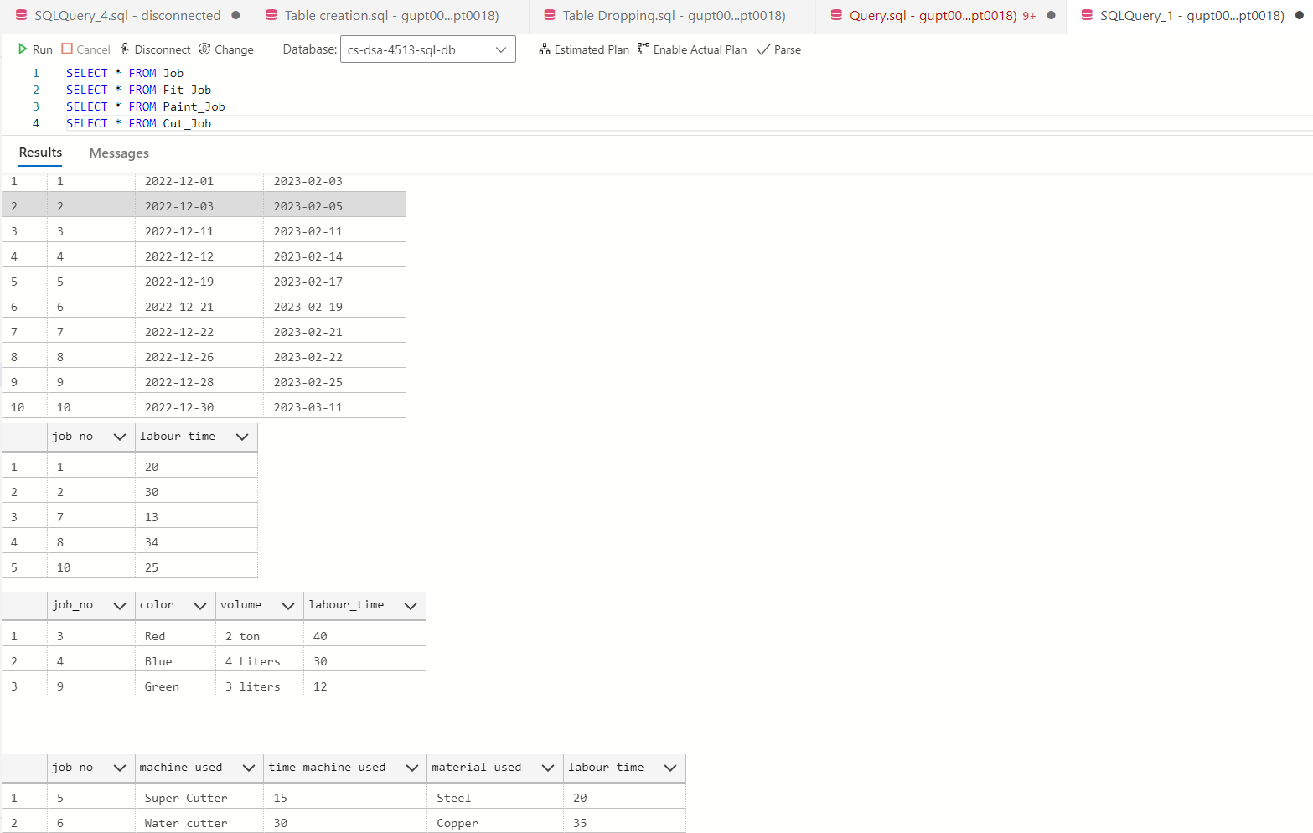

Query 8:

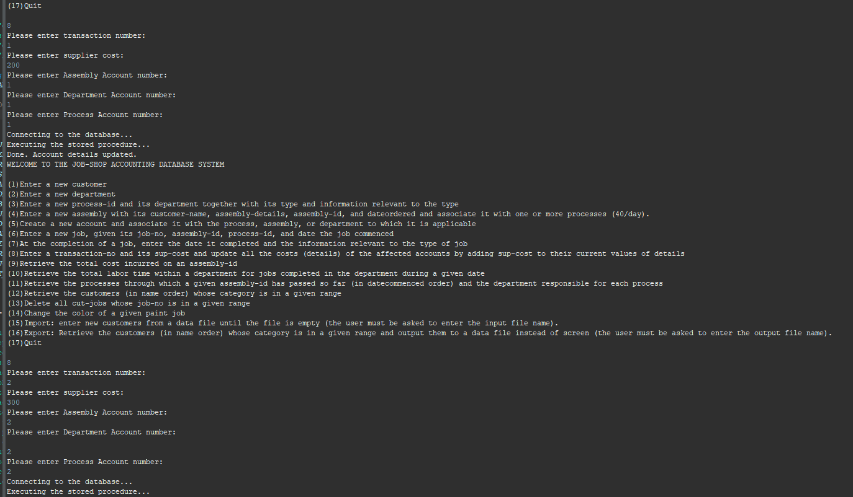

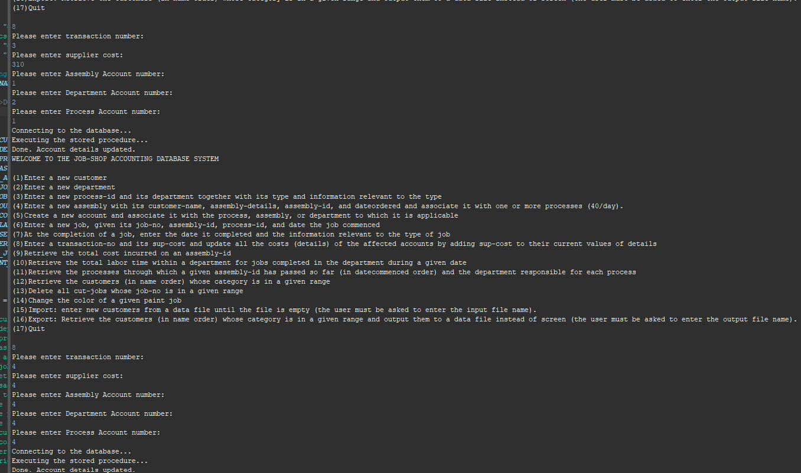

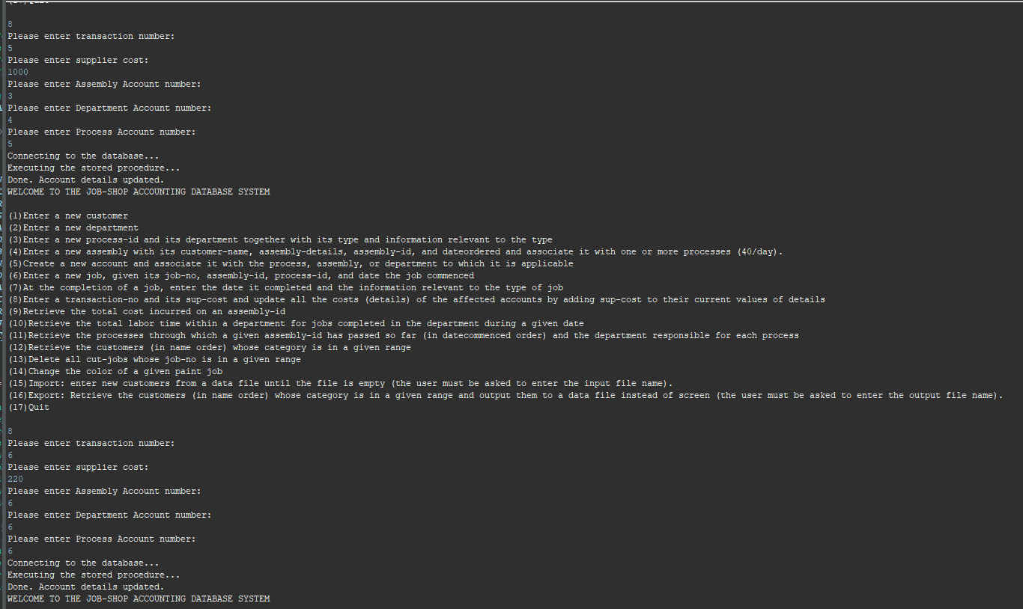

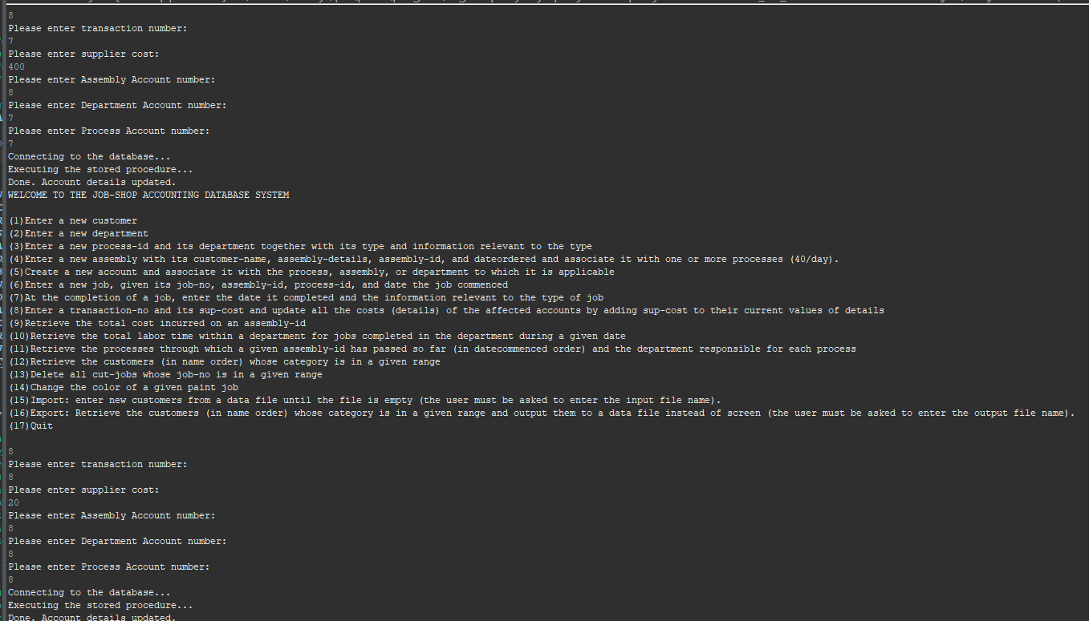

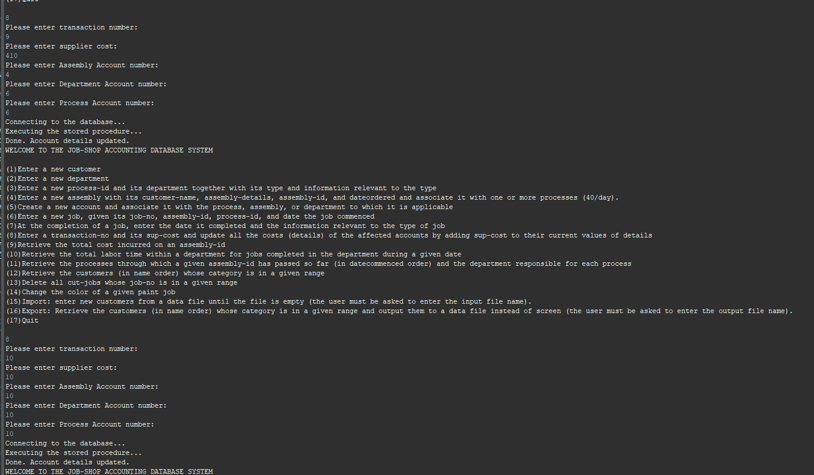

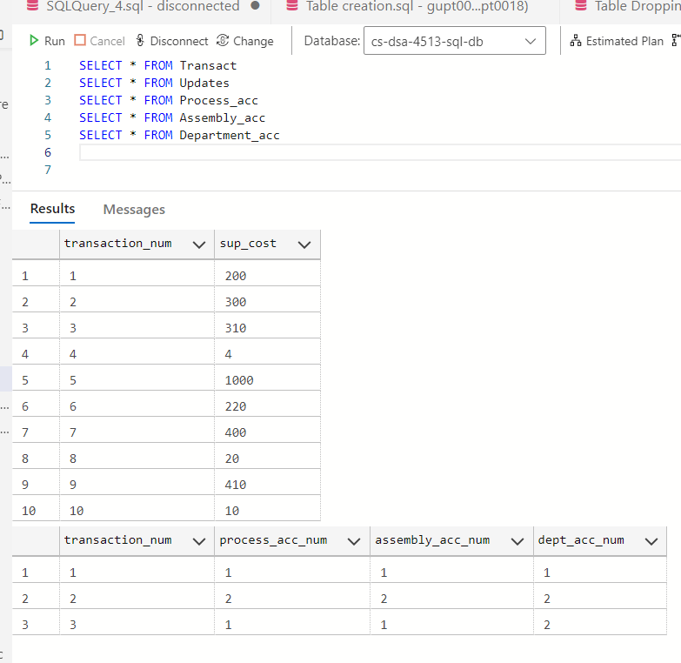

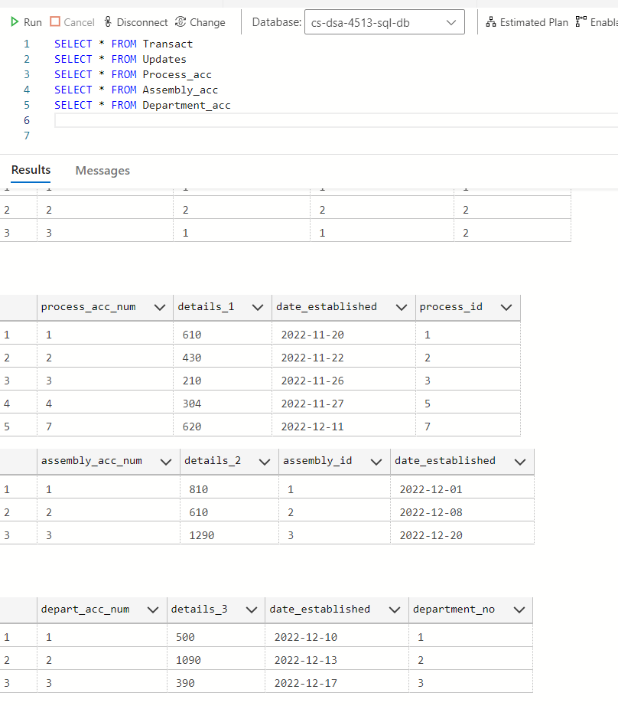

Query 9:

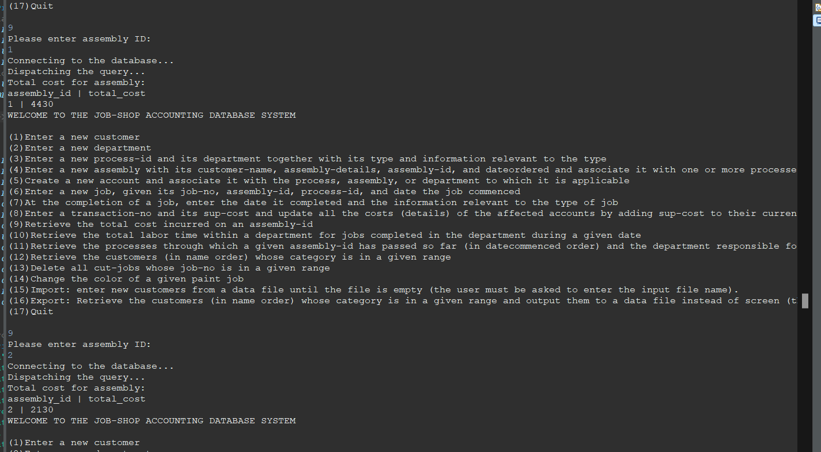

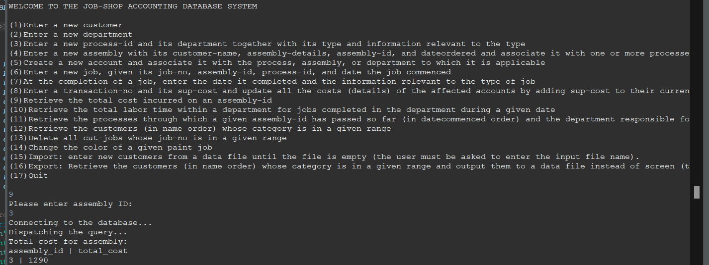

Query 10:

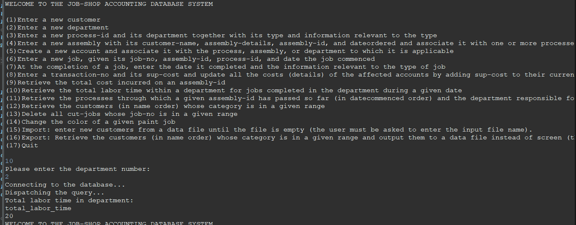

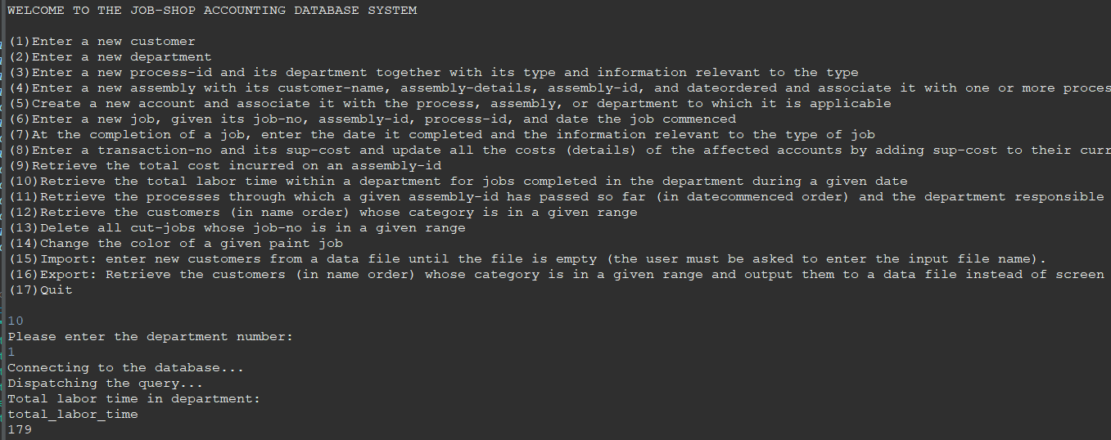

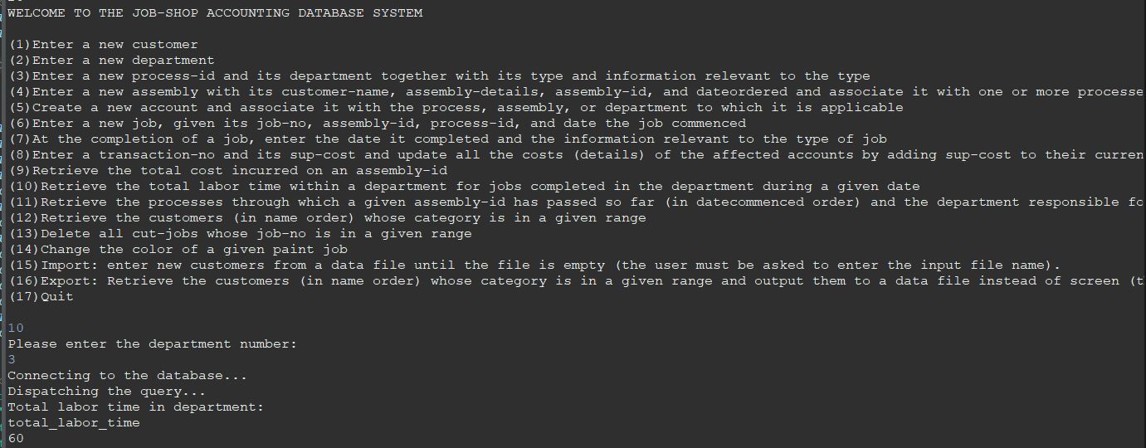

Query 11:

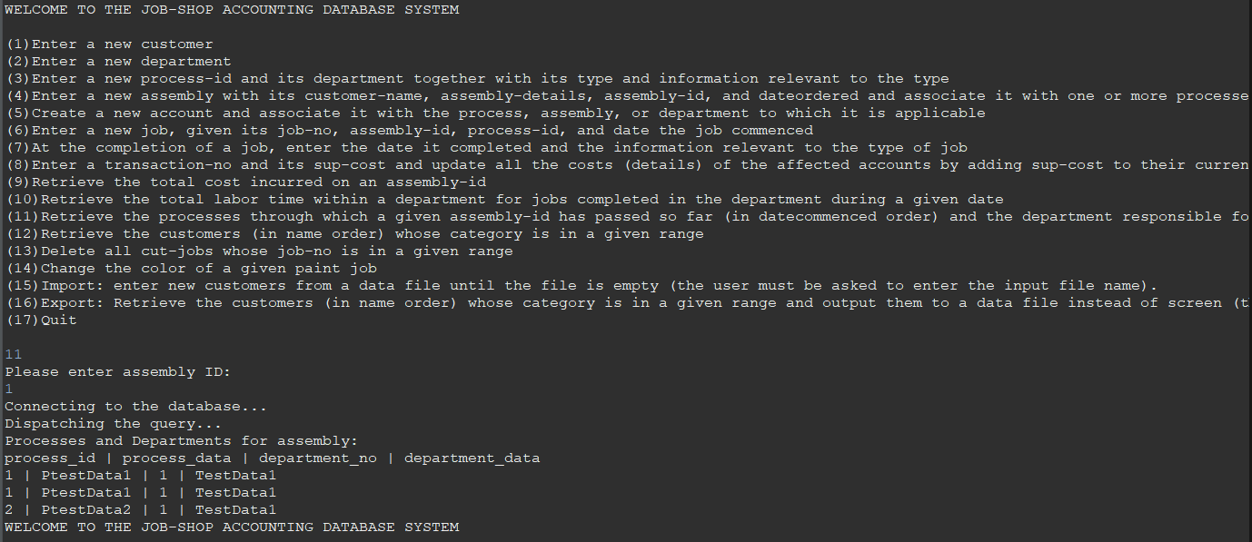

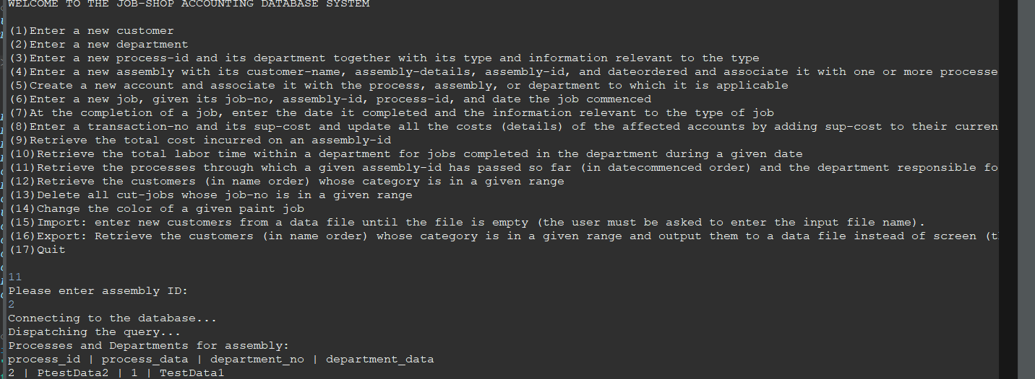

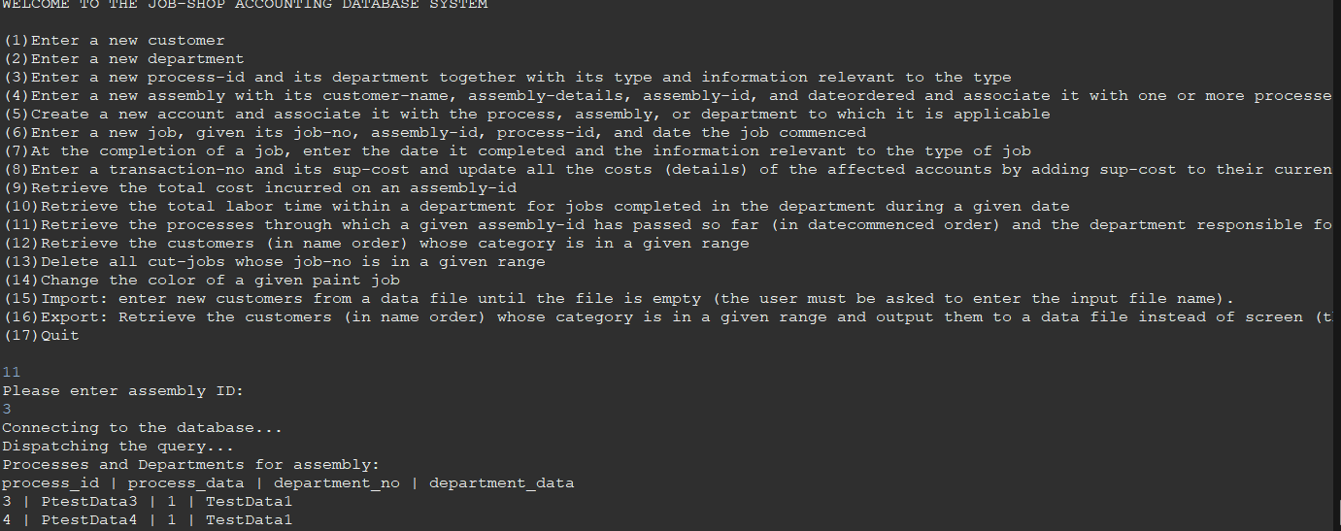

Query 12:

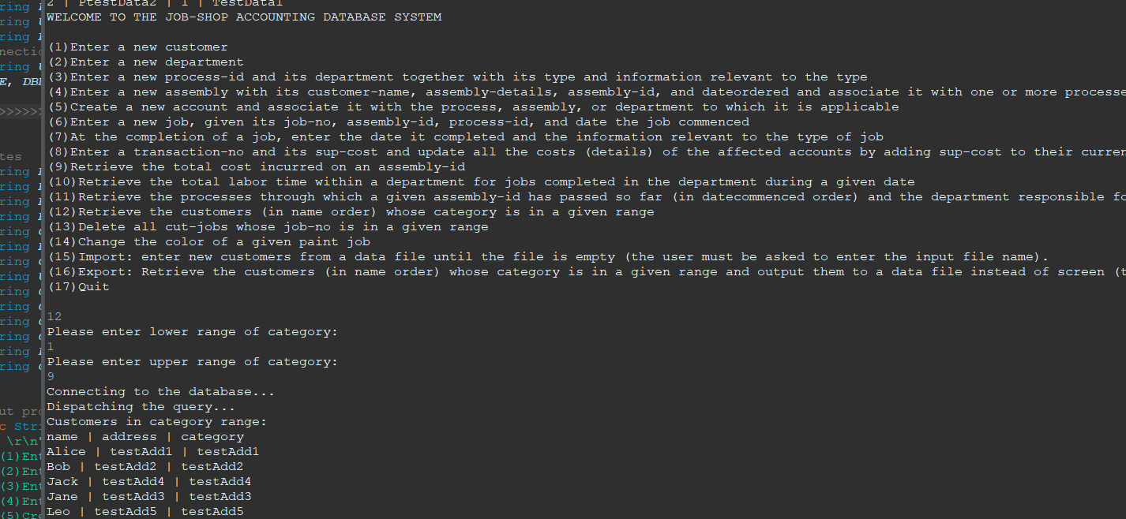

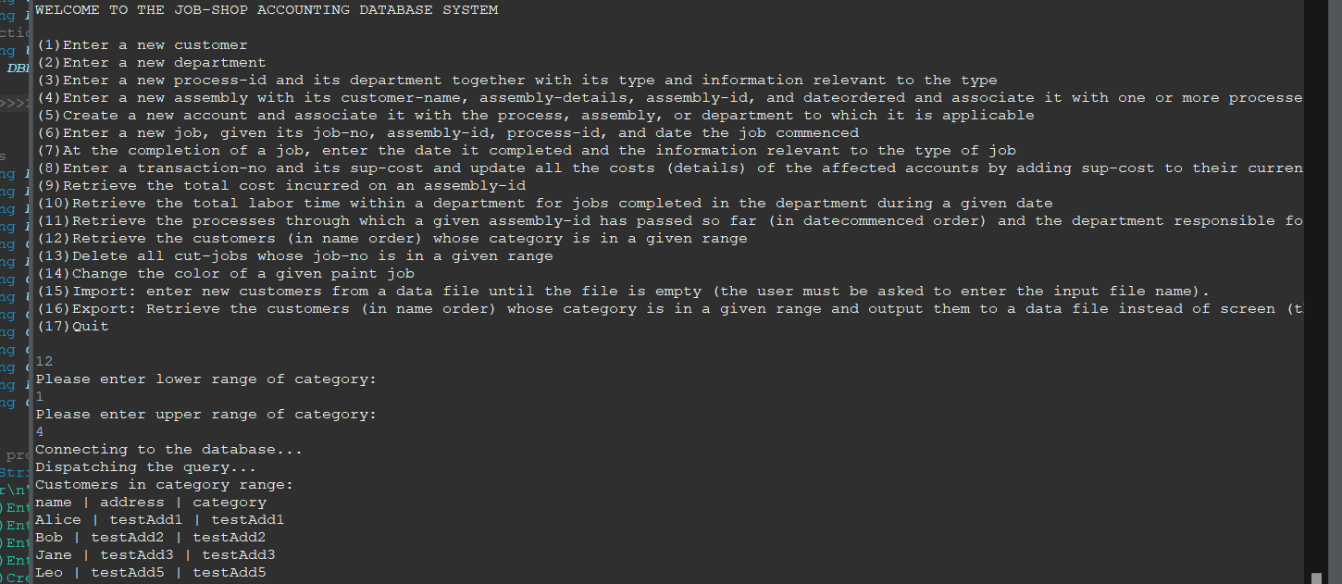

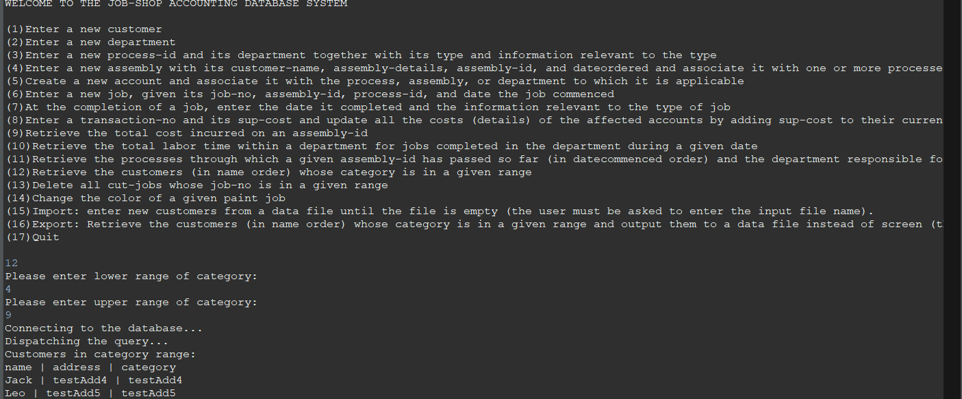

Query 13:

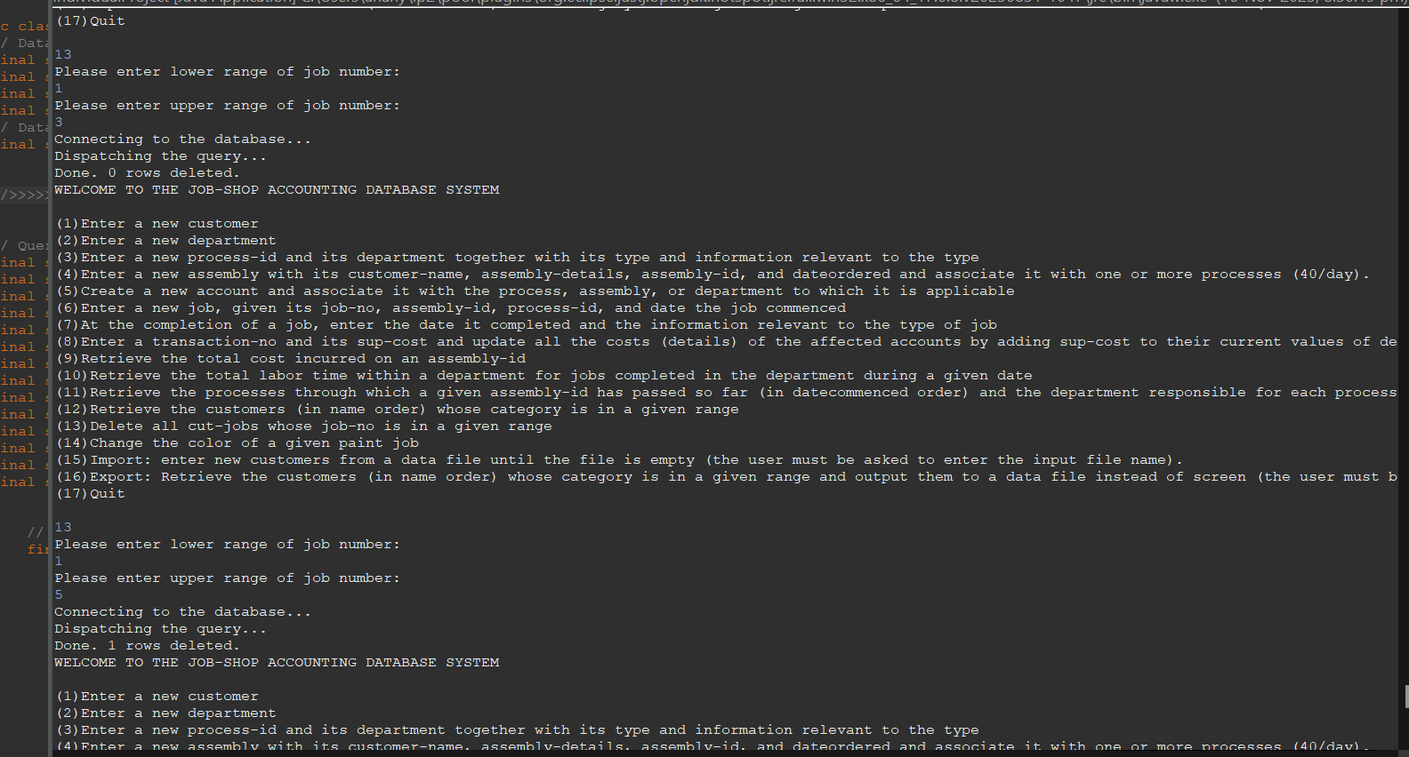

After Deleting between 1 and 5:

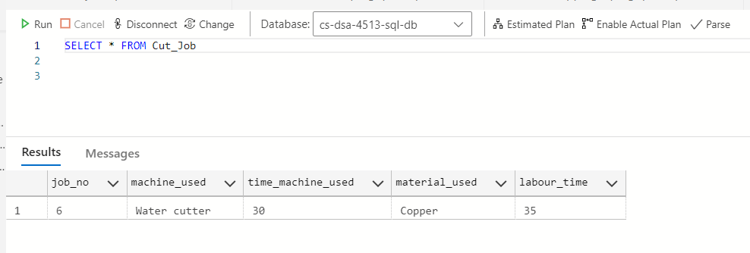

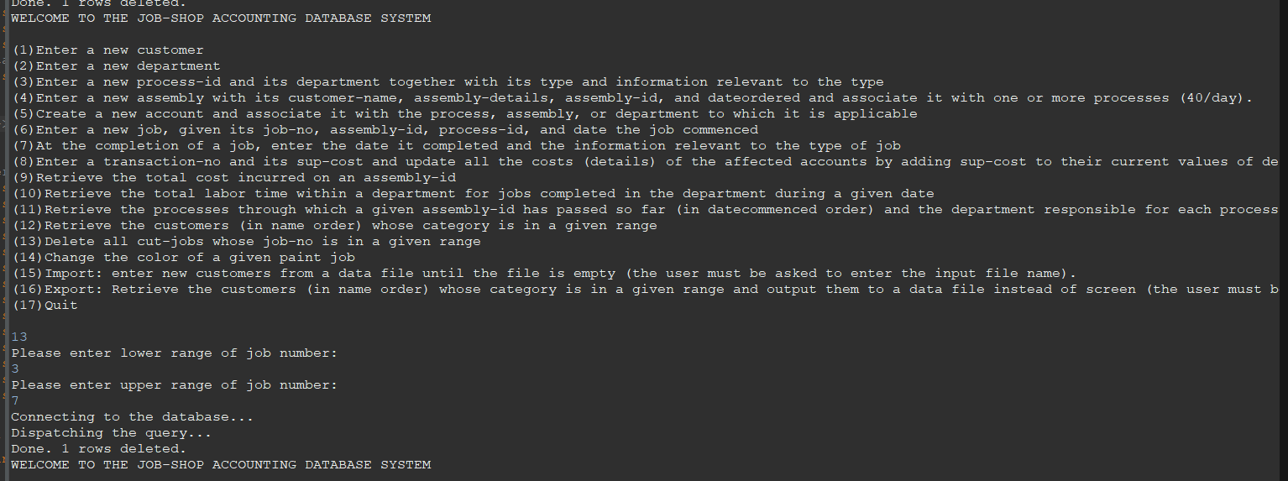

After Deleting between 3 and 7

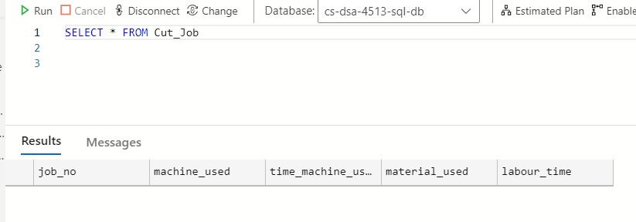

Query 14:

Before running query:

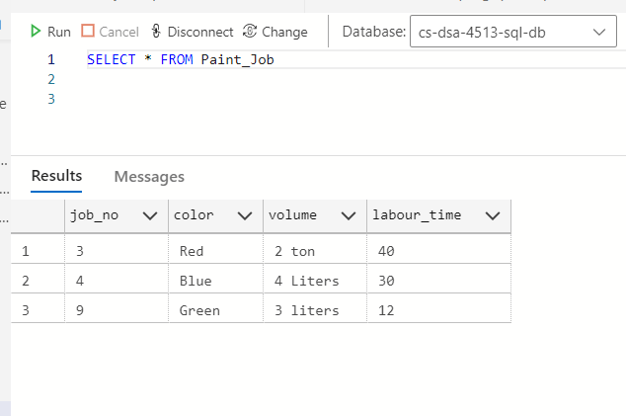

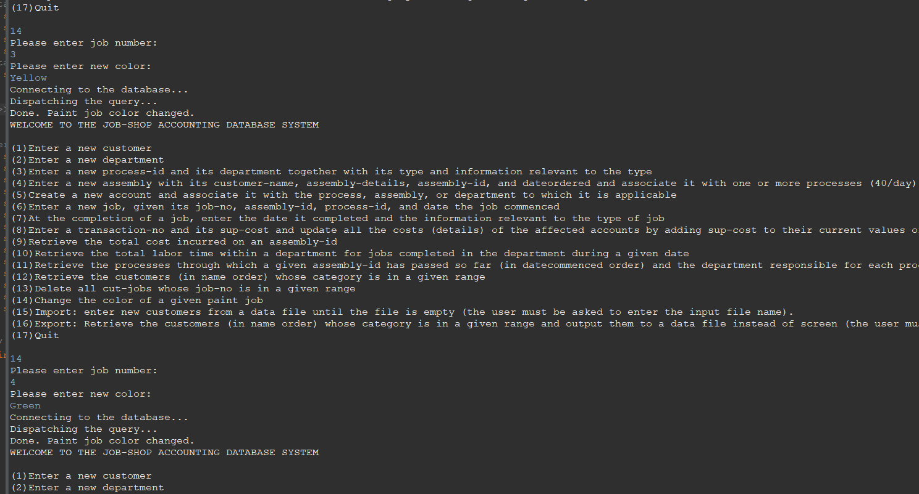

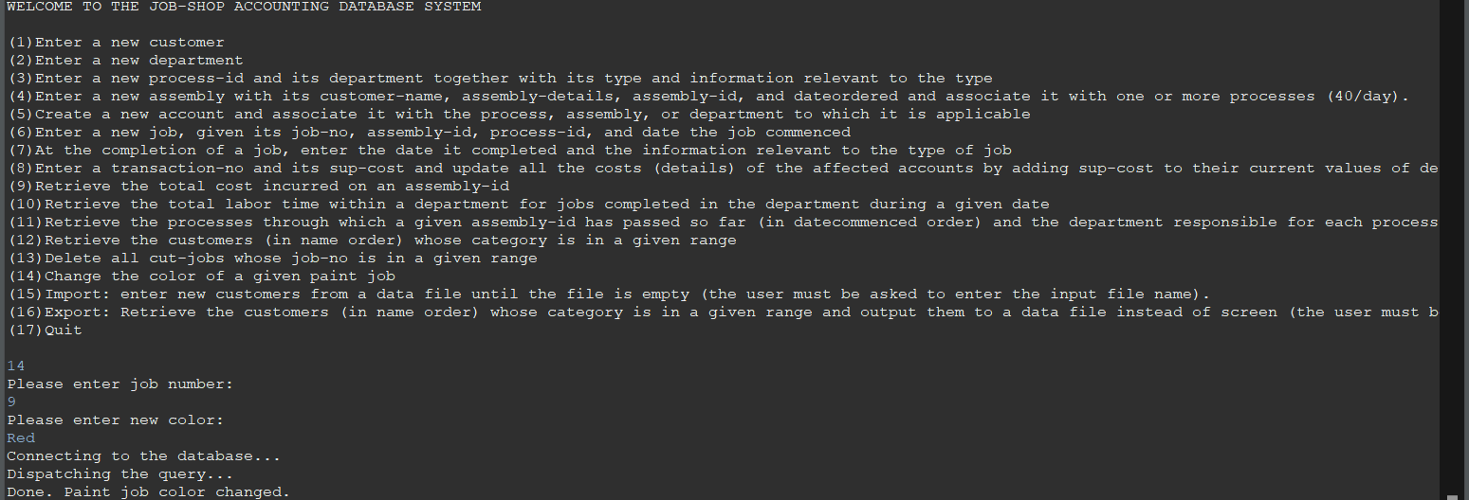

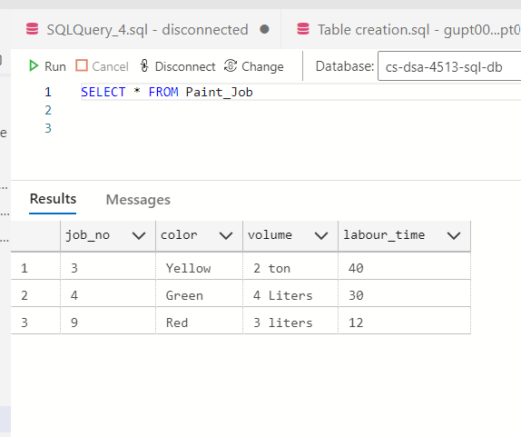

Query 15:

File input :

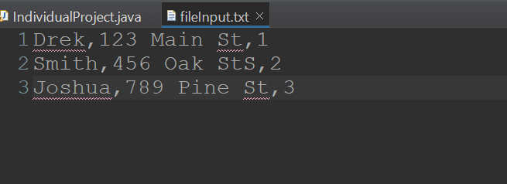

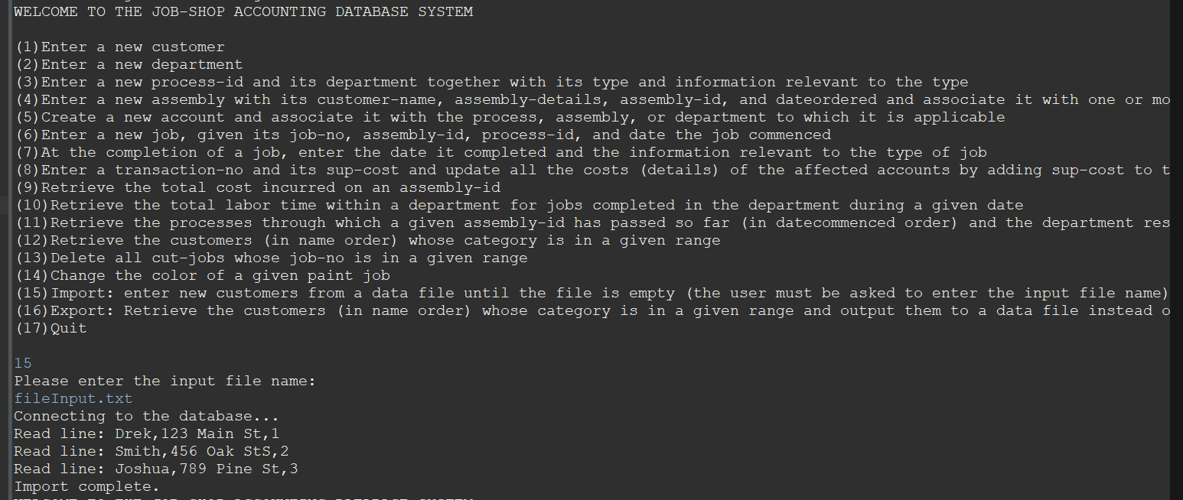

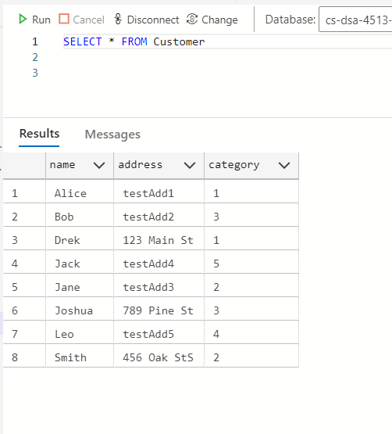

Query 16:

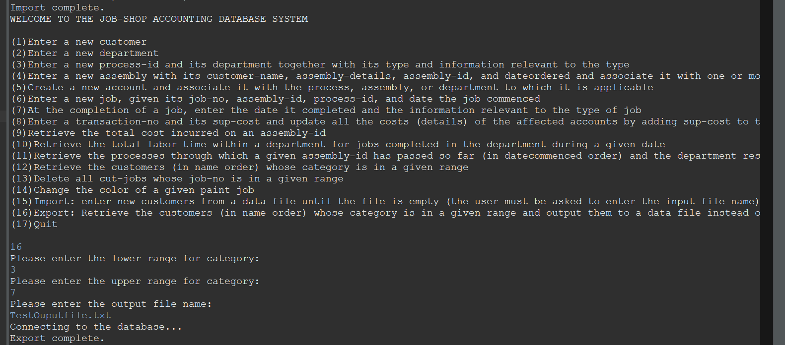

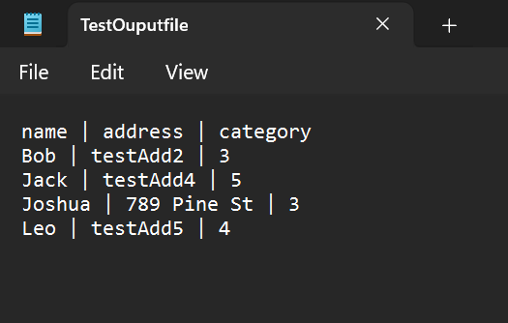

Query 17:

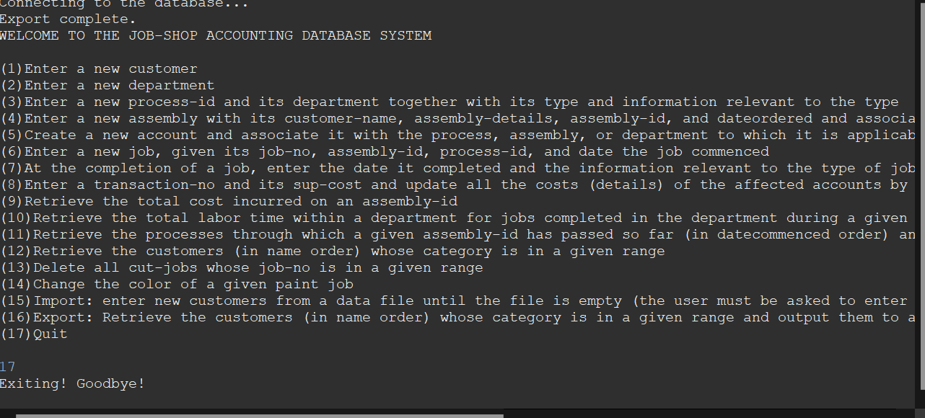

Error Generation:

